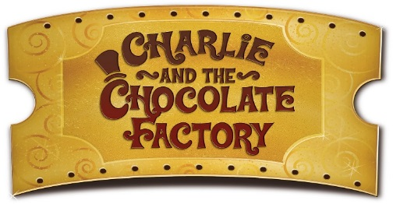

**Class 2 Newsletter**

**Term 3 2020**

Happy New Year!

Welcome back to all our children and parents and Happy New Year! It’s lovely to see that the children are ready to come back to school after their Christmas break and enthusiastic about their learning. We have a busy and fun packed term ahead!

Dates for this term

20th January – Clubs begin

27th January – Book Week

29th January – Bedtime Stories

14th February – End of Term 3

Reminders

Please remember that PE Kits are needed in school **every day** for every child**.** Without the right kit it is very hard for your child to enjoy the full curriculum within school. Our days for PE continue to be on a Tuesday and Thursday. Children also need to have a good-fitting pair of daps or trainers for outdoor PE sessions and a tracksuit or joggers for the cold weather. Please make sure all your children’s items are named so that they may be returned to the rightful owner if misplaced.

We all know that reading is one of the most important fundamental skills children (or anyone) must master to succeed in school and to succeed in life. Almost everything we do involves reading of some form. So, as always, please give your children the opportunity to read to you on a regular basis throughout the week and then to sign their reading record, so that we know how well their reading is going at home and also when to change their book.

Thank you, once again, to all parents who are allowing their children to come into the cloakroom, on their own, at the beginning of the day. By Year 2, children are very independent and should be organising themselves for the day ahead on their own, just as they do throughout the school day.

What we are learning

In term 3 we have a whole school book term, where our topics and learning are based around a book. In Class 2 our chosen book is Charlie and the Chocolate Factory by Roald Dahl. It is set to be an exciting term, with lots of ‘chocolate’ activities across many areas of the curriculum.

We will be finding out where chocolate comes from and how cocoa beans were first used thousands of years ago. Through Design and Technology the children will have the opportunity to design and create their own chocolate bar and packaging, especially for Willy Wonka!

In Literacy our focus will be on the characters and adventures surrounding Charlie and Willy Wonka’s factory. We will be using the story as a stimulus for our own writing as well as the basis for creating advertisement posters and calligrams.

In Maths we will be exploring money, recognising the coins and notes we use and combining coins to make amounts of money. We will be solving problems using money, using our addition and subtraction knowledge to help us. It would be really useful if you could practice this at home with your children or on a visit to the shops. We will also be practising and developing our learning and knowledge of multiplication and division.

Our learning in Science will focus on ‘Uses of Everyday Materials’, including wood, plastic, metal, glass, brick, paper and cardboard. We will compare the suitability of different everyday materials for different purposes. The children will also explore how objects made of some everyday materials can change shape and how the recycling process is able to reuse some everyday materials numerous times.

This term in RE our unit will be ‘Why is our world special?’ The focus here is on exploring the ideas of caring for the world. Children consider implications of the idea of God as the Creator who cares for everyone and of Hindu ideas of respect for mother earth. They learn how Humanists tell the story of creation. Children explore some of the mysteries and wonders of the natural world through poetry and symbolism and how people might show they care or don’t care for the planet.

**Thank you for your continued support.**