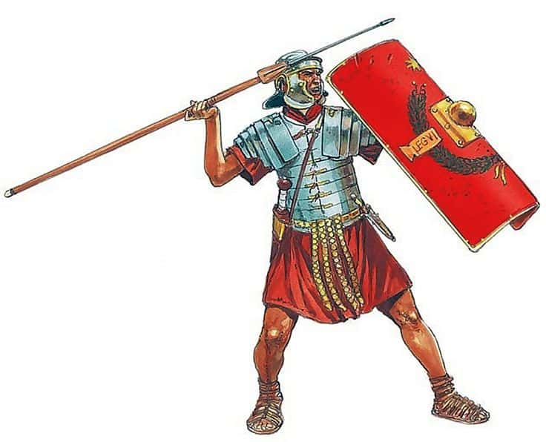
Year 3 Homework: Term 4
A huge well done to all the children for the fantastic homework produced in Term 3. I enjoyed seeing all the yummy recipes completed at home, portraits and book reviews. Keep up the hard work Class 3!
This term, children should complete one piece of homework from the list below. This is due in on a Friday. Please ensure that your child is handing in homework on a weekly basis.
- Draw or paint a picture of something from the Roman times, e.g. a Roman banquet or chariot racing. Write a description to go with it.
- Write a secret message in Roman numerals, with an alphabet key.
- Design and label a Roman outfit for a slave and/or rich person.
- Write a food diary for a day as if you were a member of a Roman household.
- Design a job advert for someone to work as a servant in a Roman villa.
- Create a maths worksheet for Roman children, making sure you use Roman numerals in your calculations.
- Find as many countries as possible that the Romans invaded. Draw their flags and write a sentence to go with each flag.
- Design, and make if possible, a Roman shield using Roman styles and colours.
- Create a Roman timeline of key events.
- Write a short newspaper report announcing the Roman invasion of Britain.
- Find an interesting paragraph about Roman life in a book. Make notes and write about it in your own words.
- Research Roman Gods and then design and label your own.
- Find a Roman recipe. Create this recipe and take a photo to show your creation. Make sure you put a copy of the recipe in your homework folder.

