

**Class 6 Newsletter**

**Term 2 2020**

WELCOME TO YEAR SIX!   
Class 6 have settled in to school life well and our first term together was great. I hope you all had a lovely break over the half term. This term is going to be another exciting one with our new topic and getting ready for Christmas. We will be learning about Remembrance Day within the first 2 weeks and then the nativity story in December.

Dates for this term

2nd November – Term 2 begins

10th November – World Science Day

11th November – Remembrance worship in school

What we are learning  
Our topic this term is ‘Ole, ole, ole!’ We will be learning all about Spain and the customs and traditions they celebrate, as well as tasting some traditional foods.

In English, we will be developing our descriptive writing and building on our grammar and punctuation knowledge. Linking with our geography topic of Spain, we will be creating our own information texts about the country.

In design technology, we will be learning to sew to create a fabric wreath in preparation for Christmas.

We will be learning about Evolution and Inheritance in Science. This will involve planning investigations, taking measurements and recording data and using scientific evidence to support ideas. We will be taking part in World Science Day and investigating the DNA of a strawberry!

In RE we be answering our enquiry question: ‘Was Jesus the Messiah?’’ The children will be continuing to develop respect and inquisitiveness through their continuing enquiry and exploration in RE. Our school value this term is compassion and we will be discussing this a lot in our worships. I have been really impressed with how well the class have been demonstrating our school values.

Useful Information

**PE**

Due to the current circumstances, children are to wear their PE kit in to school on these days to save changing. The PE kit should include a white t-shirt, black shorts and daps for outdoor activities. The children may also wear a tracksuit for outdoor PE in the colder months but no hoodies please.

**Homework**

I was so impressed with the fantastic homework presentations last term! It was wonderful to learn about each child’s hobbies!

This term, I will be sending out a piece of maths and English (reading, writing or punctuation and grammar) each week on a Friday, due in the following Friday. Spellings will be given on a Monday for a test on the Friday of that week.

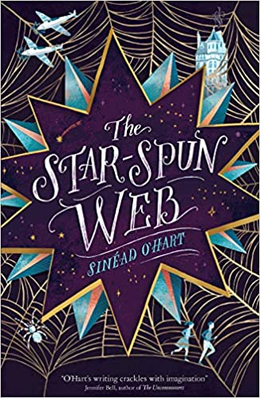

…and finally

As ever, if you have any worries or questions relating to your child and need a little more time, please do not hesitate to arrange a time to talk. It is important for us all that your children are happy at school, so please keep us informed of any concerns, no matter how small. You can contact me via email: office@stmaryswrithlington.co.uk May we take this opportunity to thank you for your continued support.

Miss Golden and Mrs Sillem

Winter Weather

Now the weather is getting a lot colder, please ensure your child comes to school every day with a warm, waterproof coat (Which is named). It’s really important that when they come to school in PE kit, they also have a waterproof coat with them. We are trying to take advantage of our amazing grounds in all weather!

Reading and Times Tables

Reading is a fantastic way to develop vocabulary and will help your child immensely in their learning. It’s been wonderful to see the children engaging with the new books we have bought across KS2 with the scheme Accelerated Reader- hopefully your child has told you all about this!

This term our class book is: ‘A Star-Spun Web’ by Sinead O’Hart – a story

of time travel and a thrilling tale of adventure.

Many children in Class 6 have already earned their times table badges,

however they are not remembering their times table facts within lessons.

Please help your child to practise their tables at home – this will help them

with so many areas of maths.

Pencil cases and Water Bottles

As we are trying to limit the number of items being brought in to school, pupils will have their own set of resources for them to use in their trays – pencils, pen, ruler, rubber, etc. As it’s important that these are not shared, pupils do not need to bring in their own pencil cases.

Some children are still forgetting their water bottles – water fountains are currently out of use and while we are able to provide cups, it would be really helpful if each child had their own water bottle in school.