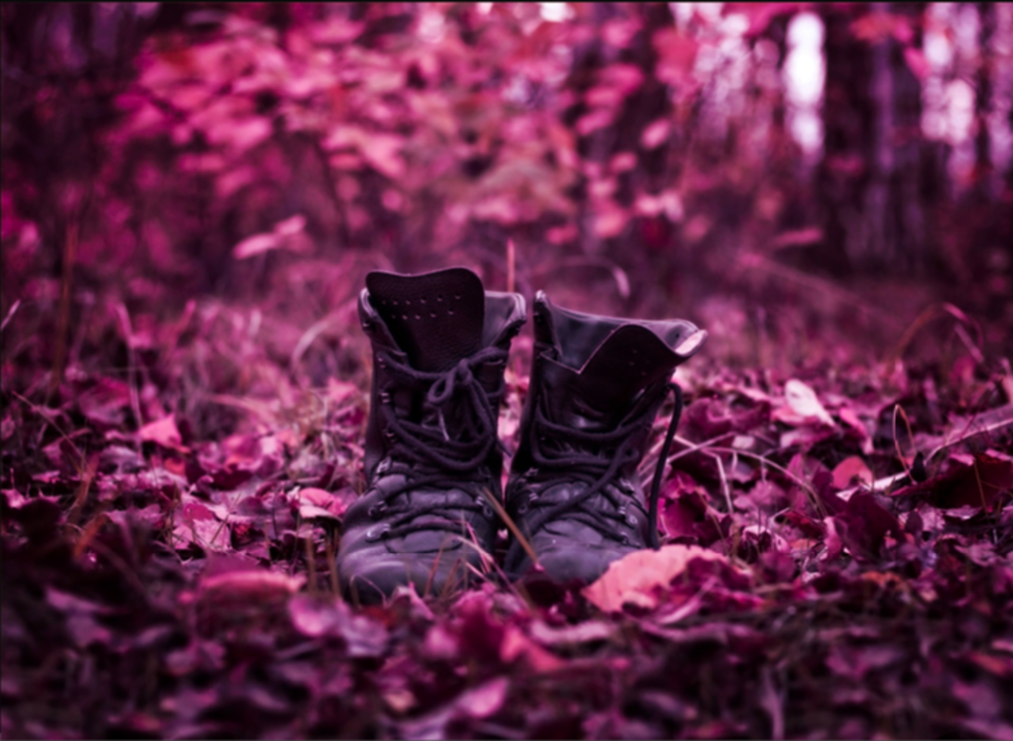
Empty Boots
All was silent in the forest. Not a breath of wind could be felt or heard.
A blanket of crisp, crimson leaves lay on the forest floor, and a faint earthy smell wafted through the tall, bare-branched trees.
The serenity of the scene was gradually broken as the empty boots began to come to life. The soft, brown leather seemed to flex, as if something had slipped inside them. The leaves rustled and crunched beneath them, as one of the boots miraculously took a step forward…
_______________________________________________________________________
_______________________________________________________________________
_______________________________________________________________________
_______________________________________________________________________
______________________________________________________________________
______________________________________________________________________
______________________________________________________________________
______________________________________________________________________
______________________________________________________________________
______________________________________________________________________
______________________________________________________________________
______________________________________________________________________
_______________________________________________________________________
_______________________________________________________________________
_______________________________________________________________________
_______________________________________________________________________
______________________________________________________________________
______________________________________________________________________
______________________________________________________________________
______________________________________________________________________
______________________________________________________________________
______________________________________________________________________
______________________________________________________________________
______________________________________________________________________
_______________________________________________________________________
_______________________________________________________________________
_______________________________________________________________________
_______________________________________________________________________
______________________________________________________________________
______________________________________________________________________
______________________________________________________________________
______________________________________________________________________
______________________________________________________________________

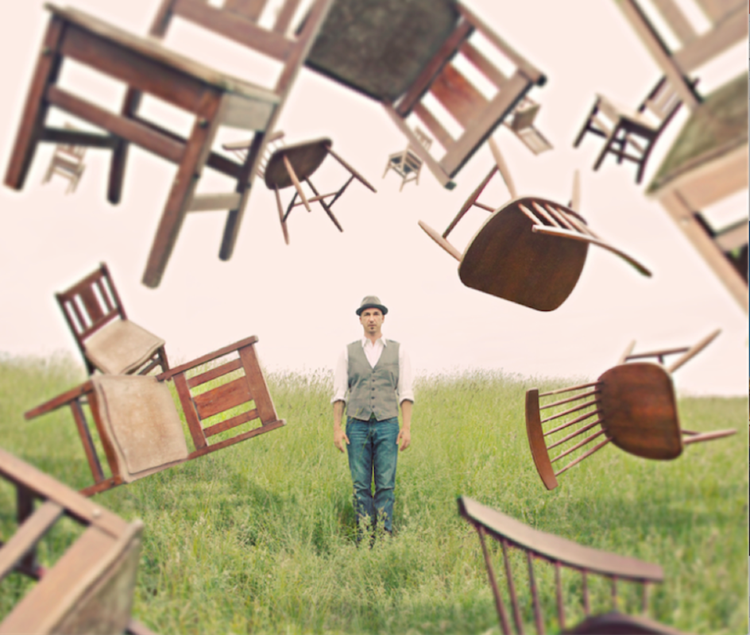
Magical...
He held them with his mind. He controlled them.
The chairs swirled around him, dancing as if held by invisible strings. He practised on chairs, however his powers allowed him to manipulate things far more complex than that…

_______________________________________________________________________
_______________________________________________________________________
_______________________________________________________________________
_______________________________________________________________________
______________________________________________________________________
______________________________________________________________________
______________________________________________________________________
______________________________________________________________________
______________________________________________________________________
______________________________________________________________________
______________________________________________________________________
______________________________________________________________________
_______________________________________________________________________
_______________________________________________________________________
_______________________________________________________________________
_______________________________________________________________________
______________________________________________________________________
______________________________________________________________________
______________________________________________________________________
______________________________________________________________________
______________________________________________________________________
______________________________________________________________________
______________________________________________________________________
______________________________________________________________________
_______________________________________________________________________
_______________________________________________________________________
_______________________________________________________________________
_______________________________________________________________________
______________________________________________________________________
______________________________________________________________________
______________________________________________________________________
______________________________________________________________________
______________________________________________________________________
______________________________________________________________________
______________________________________________________________________
______________________________________________________________________

