St Mary’s C of E Primary School, Writhlington
‘Inspiring Learning Together’
Scheme of Work + Knowledge Organiser
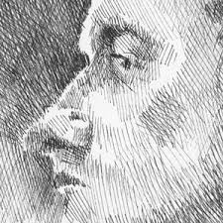
National Curriculum Knowledge outcomes:

- to create sketch books to record their observations and use them to review and revisit ideas

- to improve their mastery of art and design techniques, including drawing, painting and sculpture with a range of materials

Skills outcomes:
- Combine colours, tones and tints to enhance the mood of a piece.
Wider Curriculum (Cooking, trips, outdoor):
Developing their individual style of art and becoming more confident in their drawing style.
The Learning Journey:
LQ: Can I experiment with mark making?
Experimenting with different techniques in pencil to give a variety of ways to show tone and pattern in an image.
LQ? Can I draw a face using the correct measurements?
Using the correct face guidelines to draw a face correctly. Looking at how to ‘section’ different parts and using a mirror to help with accuracy.
LQ: Can I combine skills to create an image?
Building on the previous weeks’ learning to create a finished piece.
Key Vocabulary:
Spelling | Definition/Sentence
Depth | Foreground and background – a way of showing different perspectives
Tone | Light and dark to create a realistic object
Form | A choice of representing art work
Pattern | A structure which organises shapes
Mark making | Different lines, patterns and textures using different media
Media | Materials used to create a piece of art
abstract | Uses shapes and colours to create a representation of a picture

Topic: Art

