St Mary’s C of E Primary School, Writhlington.

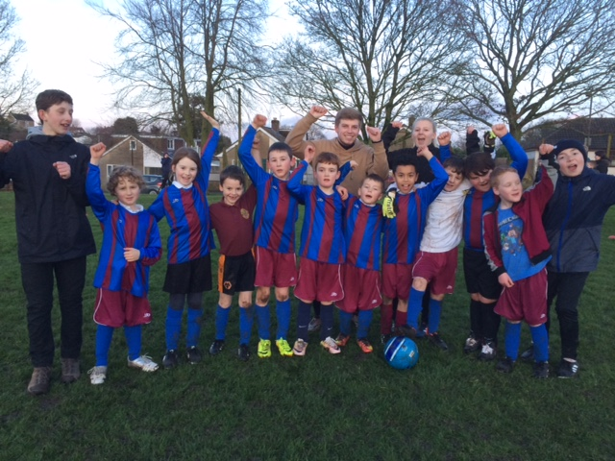
Revised July 2019
What development needs are a priority for your setting and your students now and why?
Use the space below to reflect on previous spend, identify current need and priorities for the future.

Academic Year: 2018/19 | Total fund allocated: £17,140 | Date Updated: July 2019

Key achievements to date: | Areas for further improvement and baseline evidence of need:
New football club and football coach engaging 20% of KS2 children.  Entry into MSNP Small School League for the first time  Dance Clubs (including new KS1 dance club) increasing the ability of children and positive attitudes to dance  External coaches supporting teachers  Participation at inter-school events in a range of sports:  football, cross-country, gymnastics, dance  Varied extra-curricula sports offer: Summer sports, Yoga, Football, Forest School | Although we took part in some inter-school events last academic year, we need to improve this to include all children, specifically across KS2.  Attend more festivals to improve engagement  Support staff in delivery of 2nd hour of PE  PE staff meetings/training for new staff  New PE Lead to attend MSNGA meetings/SSCO support to book events in the diary  Explore use of Writhlington Sports to support engagement e.g. tennis facility

Meeting national curriculum requirements for swimming and water safety | Please complete all of the below:
What percentage of your current Year 6 cohort swim competently, confidently and proficiently over a distance of at least 25 metres? | 100%
What percentage of your current Year 6 cohort use a range of strokes effectively [for example, front crawl, backstroke and breaststroke]? | 89%
What percentage of your current Year 6 cohort perform safe self-rescue in different water-based situations? | 89%
Schools can choose to use the Primary PE and Sport Premium to provide additional provision for swimming but this must be for activity over and above the national curriculum requirements. Have you used it in this way? | Yes. (21%)  All pupils get 20-24 weeks of swimming over Yrs 4/5.  Non-swimmers then carry on.

Schools must use the funding to make additional and sustainable improvements to the quality of Physical Education, Sport and Physical Activity (PESPA) they offer. This means that you should use the Primary PE and Sport Premium to:
- Develop or add to the PESPA activities that your school already offer
- Build capacity and capability within the school to ensure that improvements made now will benefit pupils joining the school in future years
Action Plan and Budget Tracking
Capture your intended annual spend against the 5 key indicators. Clarify the success criteria and evidence of impact that you intend to measure to evaluate for students today and for the future.

Academic Year: 2018/19 | Total fund allocated: £ | Date Updated:
Key indicator 1: The engagement of all pupils in regular physical activity – Chief Medical Officer guidelines recommend that primary school children undertake at least 30 minutes of physical activity a day in school |  |  |  | Percentage of total allocation:
 |  |  |  | 9%
School focus with clarity on intended impact on pupils: | Actions to achieve: | Funding allocated: | Evidence and impact: | Sustainability and suggested next steps:
Staff have understanding of the impact on pupil’s learning and health of Daily Physical Activity.  Pupils have understanding of the impact on learning and health of Daily Physical Activity – aware of heart beat. | All classes taught the importance of physical activity.  All pupils to know how to do a warm up, cool down and notice effect on heart rate.  Gonoodle and other activity websites used | £1,600  Buying into B&NES School Sports Partnership which includes support for Daily Physical Activity | Staff using Gonoodle  and  BBC Supermovers | Induction of new staff to include physical activity ideas.

Evidencing the impact of Primary PE and Sport Premium
St Mary’s Church of England Primary School 2018-19

Key indicator 2: The profile of PESPA being raised across the school as a tool for whole school improvement |  |  |  | Percentage of total allocation:
 |  |  |  | 9%
School focus with clarity on intended impact on pupils: | Actions to achieve: | Funding allocated: | Evidence and impact: | Sustainability and suggested next steps:
Breaktime and lunchtime play provision.  Make Sports Day a major event in ALL key Stages so that children are active and engaged not just passive spectators. | Meeting with staff and pupils on how we can introduce more physical activity opportunities for pupils at breaktimes.  Introduce scooter clubs | £1,523 | X2 meetings held with external physical activity specialist from B&NES School Sports Partnership. Footballs available at lunch and play.  Lines marked on field for longer for children to practice athletics.  Increased number (20%) of pupils scoot to school and bring in scooter on a Friday.  Sports Day success in 2018 – more children beating school records in sprint than previous years.  Parents report that running 3 sports days facilitated higher engagement. | Ongoing review meetings  Relaunch the golden mile with each child achieving personal bests i.e. able to run for 3 minutes, now able to do 7 etc.  Increase sports equipment to ensure that ALL children can engage in physical activity and play.  Train sports leaders from Year 5/6

Key indicator 3: Increased confidence, knowledge and skills of all staff in teaching PE and sport |  |  |  | Percentage of total allocation:
 |  |  |  | 24%
School focus with clarity on intended  impact on pupils: | Actions to achieve: | Funding  allocated: | Evidence and impact: | Sustainability and suggested  next steps:
Improve quality of children's physical education in Key Stage 1 and 2 to ensure they are competent and confident.  All staff to make PE lessons a priority and not a lesson that get squeezed out of the busy curriculum.  Improved role modelling of healthy active lifestyle behaviours by all school staff to reach all children. | Use of specialist PE teacher for EYFS and to support high quality PE lessons throughout school. SLT and teachers to discuss positive outcomes and what areas there are for development  Continue with Health Week (Wk 1, Term 5) to promote all areas of healthy lifestyles | £4,152 | - The focus of lessons are now child centred in EYFS and across school, and as a result pupils are engaged and are keen to learn and improve.  - As a result pupils made good or better progress both in lessons and over time (see teachers' planning).  - Almost all pupils, when questioned, said that PE lessons were really challenging and exciting and that they really enjoyed PE. | Support new staff/student teachers in school with planning for delivery of physical education.  Arrange team teaching opportunities and supportive lesson observations in order to develop the quality of teaching, learning and assessment.  Staff who need further support identified and appropriate professional learning provided.  -Further professional learning opportunities for staff who request it. For example: Teachers to buddy up and carry out peer observations to support continual learning.  - PE monitored to provide support as appropriate in order to ensure progress and achievement are maintained by all pupils.
Evidencing the impact of Primary PE and Sport Premium
St Mary’s Church of England Primary School 2018-19

Evidencing the impact of Primary PE and Sport Premium
St Mary’s Church of England Primary School 2018-19

Key indicator 4: Broader experience of a range of sports and activities offered to all pupils |  |  |  | Percentage of total allocation:
 |  |  |  | 31%
School focus with clarity on intended  impact on pupils: | Actions to achieve: | Funding  allocated: | Evidence and impact: | Sustainability and suggested  next steps:
Additional achievements:  Introduce Forest School Club  Range of sports clubs offered termly, according to children’s wishes | Ensure staff are trained. Club to run 1 hour 30 mins each week.  Ensure conservation area; fire pit and pond are cleared and accessible. | £1,450  £1,500  £1,170 | 30 children involved in club. Children enjoying forest school activities and engaged physically  High engagement 20/80 KS2 children involved.  OFSTED:  Pupils have a good understanding of how to keep themselves healthy and safe both in the school and in the local community. The curriculum helps pupils to understand how to be physically and mentally healthy. They know the importance of eating healthily and the need to be physically active. | To continue with Forest School Club. To find a way of building a shelter so that it can be all year round.  To ensure that there are sports and activities for all ages. To provide continuity so that children can excel in a sport or activity.

Key indicator 5: Increased participation in competitive sport |  |  |  | Percentage of total allocation:
 |  |  |  | 7%
School focus with clarity on intended  impact on pupils: | Actions to achieve: | Funding  allocated: | Evidence and impact: | Sustainability and suggested  next steps:
Enter new sports fixtures:  Small School Football League  Cross country  B&NES Swimming gala  Dance Umbrella | Football coach and club  Select a team to compete in swimming gala. | £1,170 | School entered MSN Small School League. Children highly engaged in football (and play all lunch time). Massively increased participation in the sport and enjoyment in physical activity. | To keep improving in order to win some matches.  PE lead to build into school calendar and raise profile of PESPA among staff.  Increase the number of sports clubs available to children – survey for interest. Possible netball, rugby and/or tennis

