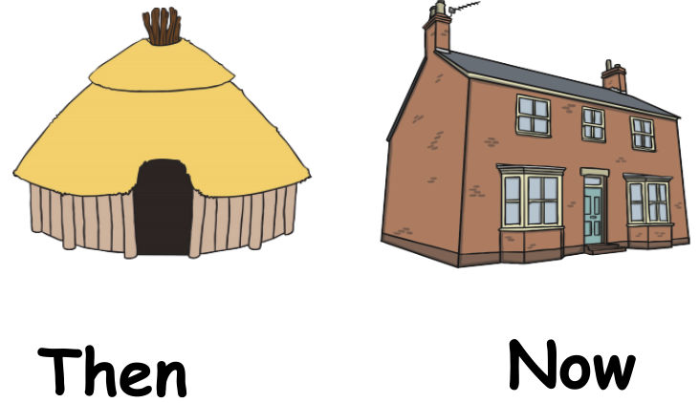

**Term 5**

**2019**

**Class 1**

**Newsletter**

**SUMMER TERM**

We’ve already met the Summer Term full on and your children have been working hard on their new topics. We are really looking forward to these two terms, with lots of exciting and interesting things for the children to do both in and out of the classroom. The Summer Terms promise to be really busy including-health week, sports day, and summer fair - plenty of things to look forward to. We’d better get cracking!

**Dates for this term**

Wk. beg 10th June – Phonics testing

**What we are learning**

Our topic this term is ‘A Street Through Time’. We have already made Dens and the children have had the chance to talk about their Holiday Homework on Radstock. It was great to see all their photos, drawings, paintings and research.

In Literacy, we will be reading and writing about Dinosaurs and learning Dinosaur poems.

In Maths, we continue to practise our 2x, 5x and 10x tables, count confidently to and back from 100, learn number bonds to 10 and 20 amongst many other number processes. We will also be beginning the basics of division and multiplication by sharing equally and talking about odd and even numbers.

In Science, our topic is ‘Everyday Materials’ so as well as learning about materials and their properties, we will be testing why some materials are better suited for certain purposes than others.

Our Computing sessions this term will cover many aspects of ICT, including Internet safety and blogging.

The Year 1 Phonics Screening Test is coming up in early June. We are mostly revising sounds and their corresponding graphemes that the children have already learnt in preparation. If you want to help your child at home then do have a look at the booklet we are sending home. There are lots of tips and websites to work with.

In D.T. we will be making puppets, including sock puppets. If you have any clean, spare socks we could use then do send them in.

Thanks very much to our fantastic mum helpers who have heard all the children read every week so far this year. The children are all making such good progress.

**Useful Information**

**PE**

In Class 1 PE will still be every Monday and Friday. However, please make sure that your children have their PE kit in school at all times as there may be other opportunities for children to do physical activities throughout the week. Some of these may well be outside, particularly as the weather warms up. At St Mary’s our PE kit should include a white t-shirt, black shorts and daps for outdoor activities.

Please can you make sure all items of clothing are named. Children are always misplacing their jumpers or cardigans and once named they are so easy to return to their rightful owner!

Also, as the weather (hopefully) starts to improve, can you make sure that your child is sent to school with a sun hat and have sun cream applied before school if necessary. Thank you.

Homework

Reading with your child is still the most important aspect of Year 1 homework. We are also sending home weekly phonics practise, linked directly to what the children are learning in their daily phonics sessions.

As ever, if you have any questions or want to have a chat then please come and see us either in the morning or at the end of the day.

Many thanks for your continued support.

Mrs Dart, Mrs Martin, Mrs Webb and Miss Buchan.

Your Year 1 team.

…and finally

It is very encouraging to see many parents saying goodbye to their children at the gate and allowing them to come in independently. The children benefit greatly from this and it means that they can settle much more quickly and quietly and become more independent.

As ever, if you have any worries or questions relating to your child please do not hesitate to catch us after school when you collect your child. It is important for us all that your children are happy at school, so please keep us informed of any concerns, no matter how small. May we take this opportunity to thank you for your continued support. We look forward to meeting you all at our forthcoming Parents Meeting, if not before.

Yours sincerely

Mrs Roberts, Mrs Martin, Miss Buchan and Mrs Appleby.