31st January

Dear Parent/Carer,

Thank you to all of you who have come to our Little Oaks Reading Café so far. The purpose of the Café is to share a different picture book each week and for the children to go home with something they have made during the session. The resources they make are for you to re-tell the stories at home with your child. This is quite a hands –on session so we do ask that all parents/carers come along whenever this is possible. If you cannot attend, please feel free to send another family member in your place, for instance, an older sibling. Or speak directly to Mrs Martin.
Here are the things we have made so far:

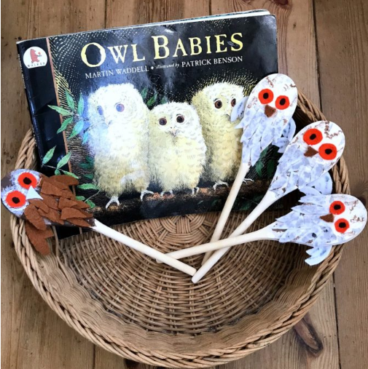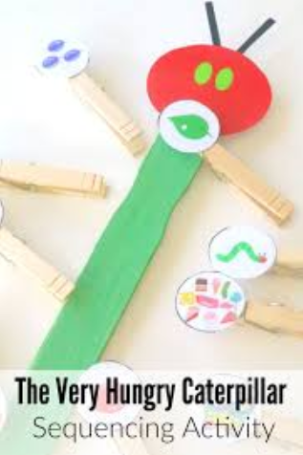

Next week our book will be…
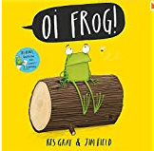

We look forward to seeing you all again next week!
Mrs Martin, Miss Hamblin, Mrs Hazelton and Mrs Sillem.

________________________________________________________________________________
Please return this form to Mrs Martin or Miss Hamblin
Child’s Name___________________________
Yes I can come to the Reading café on 16th January

No I cannot come to the Reading café on 16th January

