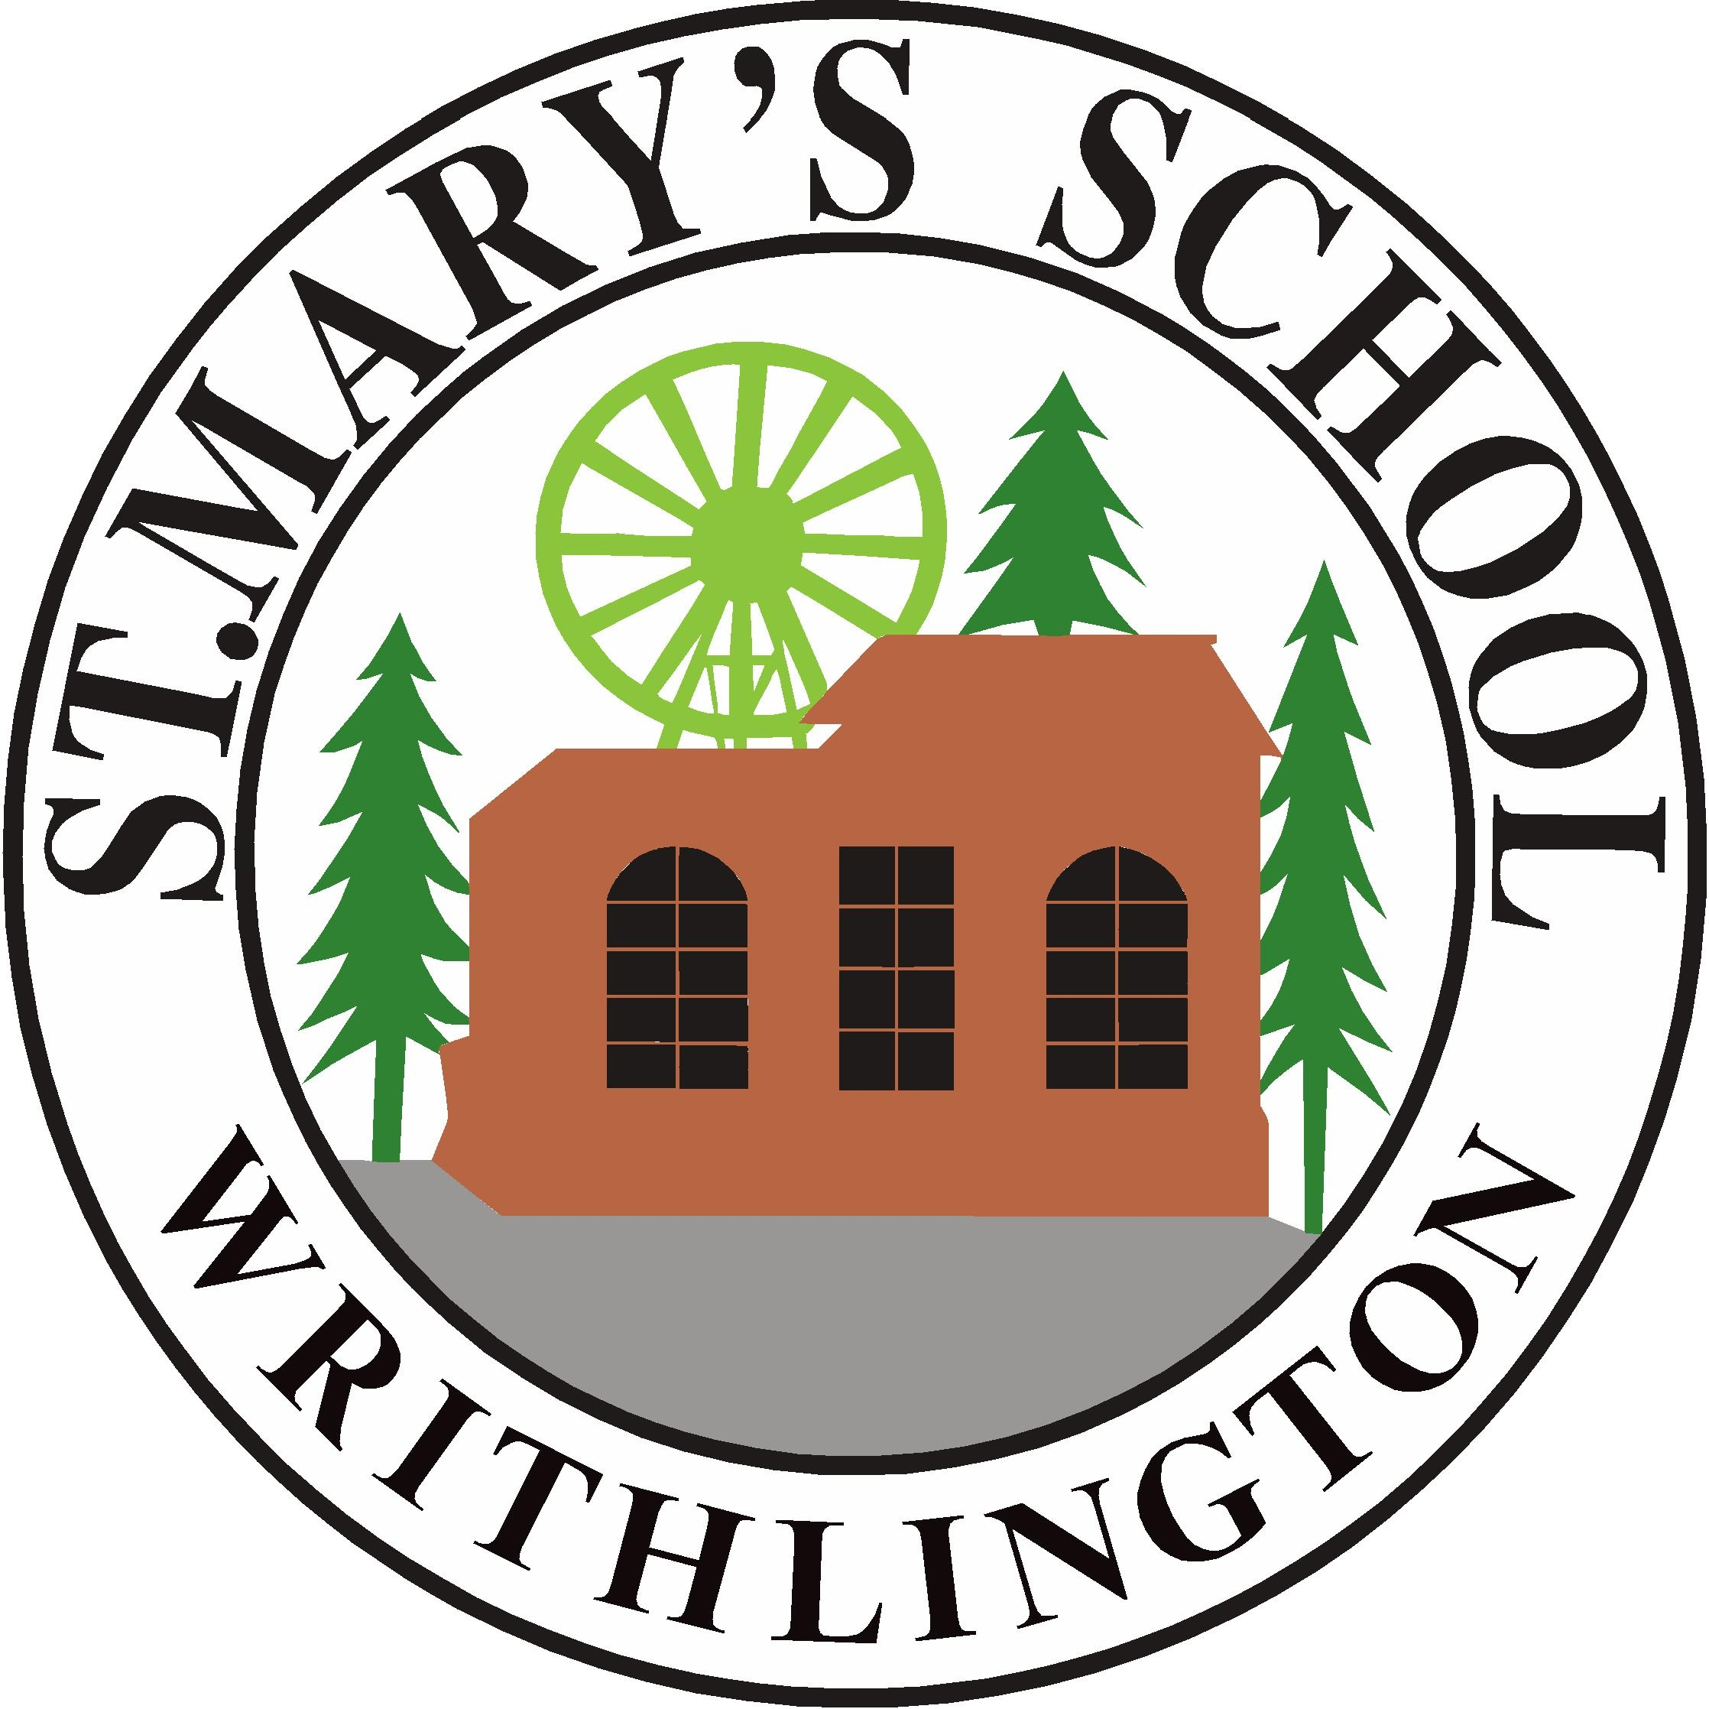
St Mary's Church of England Primary School & Nursery

Old Road, Writhlington, Radstock, BA3 3NG
Telephone 01761 434548
email: stmaryswrithlington_pri@bathnes.gov.uk
website: www.stmaryswrithlington.co.uk

Headteacher : Cathie Lampert
Deputy Headteacher: Beth Hamblin

Dear Parents and Carers,

As you are aware the Prime Minister has asked Head teachers to prepare for a possible gradual start to reopening schools on the 1st of June “at the earliest”. I need to reiterate that at this time this has not been confirmed and may not be confirmed until during the half term break. Please do make plans but do not assume it is definitely going to happen! These are our current plans but are most definitely likely to change to include the MOST UP TO DATE advice during these dynamic times.

We have been asked to focus on Nursery, Reception, Year 1 and Year 6, key worker families and vulnerable children. I realise that for many families this will mean having to make a decision whether or not they are going to send part of their family to school whilst still having children at home.

The children of key workers and pupils deemed vulnerable, who already have places will continue to attend. If you are a key worker and have not previously used our key worker provision, we will do our best to accommodate you but the number of places will be limited due to the restrictions put in place by the Government. Please contact the office or email the school if you wish to be considered for a key worker place.

The Government, in its document, has made it clear that young children will not be able to keep to social distancing rules and certainly that is our experience with the children here.
In choosing to send your child back to school you are agreeing, and understand, that it is impossible to maintain social distancing between the children and the staff and children. Whilst the staff will do their best to protect the children and remind them not to get too close, we also understand being close to their peers and playing with them is a natural part of childhood.

Returning pupils, apart from Key Worker children are expected to attend every session unless they are unwell.

The Government has asked head teachers to make a plan to do our best to mitigate the risk of transmission of Covid-19 from family to family and to staff at school. We will be doing everything we can to keep our community safe.

In School:
- No child should attend school if ill. Should any member of the household display symptoms, all should be tested.
- Each year group is going to be split in half, apart from Nursery.
- Children will be in groups of a maximum of 15. We are calling these ‘Bubbles’. For example Nursery Bubble, Little Oak Bubble A, Little Oak Bubble B, Year 1 Bubble A, Year 1 Bubble B, Key Worker Bubble etc.
- The children will not necessarily be taught by their current teacher, or in their current room, but we would ensure that they are with a familiar member of staff.
- In adhereing to government guidelines, the classrooms and our school look very different but will be filled with the warmth, support and kindness always shown by staff at St Mary’s.
- Resources e.g. pens/pencils have been allocated for each child and play equipment for the class.
- All pupils will be reminded to stay apart: a new behaviour policy will reflect this. There will be a timetable for play and lunch times.

Little Oaks
You will have noticed that Little Oaks will be in school part-time. There are a number of reasons for this but all decisions have been made with all the children at St Mary’s at the centre. We believe that children returning to school will be better placed in their ‘own’ classroom, with their usual teacher, to support their own well-being. There were a number of alternatives but unavoidably some children would have ended up in a different room with a different teacher to avoid cross contamination of ‘Bubbles’. Additionally, this model for Little Oaks will not only support their transition back into school but also allow for thorough cleaning of all toys, work spaces and equipment mid week. The government has suggested that all children will be back in school a month before the summer holiday. We believe that this situation is temporary, possible only for a few weeks. It is likely to change and will be reviewed regularly by teaching staff, Senior Leadership Team and governors.

Draft timetable for return:
Half term – School closed | School closed
Monday 1st June/ Tuesday 2nd June | Closed to pupils except key worker’s children and those pupils deemed vulnerable.
Wednesday 3rd June | Year 6 return
Thursday 4th June | Year 1 return
Friday 5th June | Nursery class returns
Monday 8th June | Reception class - Bubble A returns
Thursday 11th June | Reception class - Bubble B returns

Drop off and pick up times:
To minimise the risk, the school day has had to be tweaked. It is imperative that these times are adhered to. If you are running late, you will need to wait until all of the year groups have been dropped off before we will be able to accept your child, as we are not able to mix the groups.

Year group | Drop off | Pick up
Key worker and those deemed vulnerable | Between 8.30 – 8.40 | 3.15
Year 6 | Between 8.45 – 8.55 | 2.30 (11.45 Friday)
Year 1 | Between 9.00 – 9.10 | 2.45 (12.00 Friday)
Year R + Nursery | Between 9.15 and 9.25 | 3.00 (Nursery - 12.00 Wednesday)

To allow for thorough cleaning of the classrooms, school will finish for pupils in Year 1 and Year 6 at lunch time on Friday. The Nursery will be cleaned on Wednesday afternoon.

NB pupils must not be brought to school or picked up by anyone outside of your household – this contravenes government rules.

Additionally, the government has said that currently adults and children should not be with more than one person not in their household. This should be outside and 2 metres apart. We expect that children attending school have followed these rules strictly. Should households or children not be following these rules we would expect them not to attend school. Please ensure children DO NOT play with others outside their household.

The following measures will be taken to try and reduce the possibility of Covid-19 transmission:
- No parents will be able to enter the school.
- Parents should wait, before school, with their child following social distancing requirements, 2m apart from other households, on the pavement or on the park playing field. Children should not play together as this risks cross-contamination of ‘bubbles’ in school and is against government guidelines.
- Only one adult should accompany the child to school.
- Teachers or teaching assisstants from each ‘bubble’ will meet children at the school gate at their allotted time and call children by name to come onto the school premises
- No books will be sent home.
- Nothing should be brought from home. This includes: book bags, rucksacks, pencil cases, gym kits, except for lunchboxes and water bottles which should be taken home and cleaned thoroughly each day.
- Parents will need to provide lunch boxes for the first two weeks. After which we would hope to be able to provide Free School Meals to pupils, infant lunches and any ordered from Year 6.
- Until our fruit delivery resumes, please could parents provide a healthy, fruit snack for morning play.

Uniform
- Our absolute priority is that children should attend school in clean clothes each day.
- Children are not expected to wear uniform but are expected to wear suitable clothes for school e.g. plain t-shirts/shorts/trousers, summer dresses. No hoodies, apart from Year 6 leavers.
- All cardigans, jumpers and coats MUST be labelled.
- Children should additionally ensure that their footware is suitable for P.E. – trainers are advised. No sandals, flip flops, or flimsy daps/plimsolls – the children will be doing lots of activities outside
- Long hair MUST be tied back securely.
- Sun hats MUST be worn by ALL children and labelled with their names. Sunscreen can be applied prior to school.
- Raincoats MUST be brought to school by ALL children and labelled with their name, if needed.

Cleaning
A cleaner will be in school most of the day. She will be rotating around the school cleaning taps, toilets, door handles etc.
Older pupils will be required to clean down their desks and equipment at intervals throughout the day as directed by their teacher with paper towels and food safe disinfectant spray provided by the school.

Handwashing
Pupils will be required to wash their hands
- On arrival in school.
- After each section of learning
- Before snack
- After snack
- After playtimes
- Before lunch
- After lunch
- After using the toilet
- Before leaving to go home
Parents may wish to supply hand cream, abelled with the child’s name, for children to apply independently. Soft toys and dressing up clothes have been removed from the EYFS classrooms. Plastic toys will be washed on a cleaning schedule after use.

Work for pupils not attending school
Paper packs will be available to be picked up during the first week of next term for all year groups. Pupils in school will completing similar work. Please collect packs from Monday 1st June. Home Learning will continue but please understand that the amount of time available to many staff to message children and parents will be reduced as many of the staff will be needed in the classrooms. We will do our best though!

Year 6 Leavers
Currently it will not be possible to do a leavers service or production. Our plan to have a celebration as soon as possible remains the same – we will make sure they have the proper send off in the end! Year 6 pupils may wear their hoodies to school from whenever they arrive! We have not heard of any plans for
transition for Year 6 pupils, as yet.

Illness
Pupils who are ill will be sent home. Those showing even the mildest symptoms of COVID-19 will be isolated in our deemed ‘isolation room’ on their own with a member of staff 2m away. Parents will be expected to book household testing and the child will not be allowed back to school until the results are known. Should any child test positive for COVID-19 the Government guidelines will be followed.

I understand that many of you are struggling to decide whether or not to send your children back to school. Again I have to re-iterate that we will do everything we can to protect everyone but we cannot guarantee that we will succeed. This is an ever changing picture so I apologise in advance for any changes that may occur going forward. The government has confirmed that any child not attending will not face any fines or legal action.

I really appreciate everything that you can do to support us in bringing the children back to school.
If you have any questions please email me on stmaryswrithlington_pri@bathnes.gov.uk.

Stay safe everyone.

Best wishes,

Cathie Lampert Frances Butt

Headteacher Chair of Governors

