St Mary’s C of E Primary School, Writhlington
‘Inspiring Learning Together’
Scheme of Work + Knowlegde Organiser
Wider Curriculum (Cooking, trips, outdoor):
Class assemblies, whole school worship
Key Vocabulary:
Spelling | Definition/Sentence
Gospel | the record of Christ's life and teaching in the first four books of the New Testament
Trinity | the three persons of the Christian Godhead; Father, Son, and Holy Spirit
Incarnation | a person who embodies a God or deity in the flesh
Baptism | a ceremony performed by Christian churches to show that a person has become a follower of Jesus

Knowledge outcomes:
- Identify the difference between a ‘Gospel’, which tells the story of the life and teaching of Jesus, and a letter
- Offer suggestions about what texts about baptism and Trinity might mean
- Give examples of what these texts mean to some Christians today
- Describe how Christians show their beliefs about God the Trinity in worship and in the way they live
- Make links between some Bible texts studied and the idea of God in Christianity, expressing ideas about what God of Christianity is like

The Learning Journey:
Why was the baptism of Jesus important to Christians?
What do Christians believe about the Trinity?
What is a baptism and what do they symbolise?
What was John’s Gospel?
What difference does it make to believe in God the Father, Jesus and the Holy Spirit?
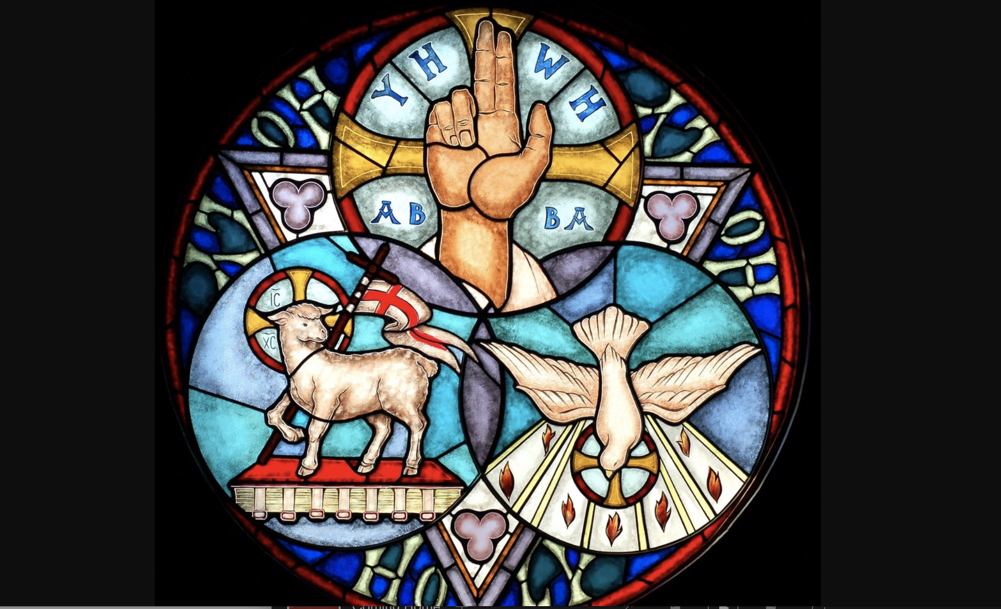
Incarnation – What is the Trinity?

