St Mary’s C of E Primary School, Writhlington
‘Inspiring Learning Together’
Scheme of Work + Knowlegde Organiser
Key Vocabulary:
Spelling | Definition/Sentence
felt | a cloth made by rolling and pressing wool
decoration | the process or art of decorating something with a material
design | a plan or drawing produced to show the look, function or workings
product | something that is manufactured for sale
evaluate | to determine the level, value or worth of something
stitch | an in-and-out movement of a threaded needle in sewing
running stitch | a stitch created by running the needle and thread through the layers of fabric

The Learning Journey:
Can I analyse a range of tree hanging decorations?
Children to discuss common features to tree hanging decorations and make sketches of the different designs.
Can I design a tree hanging decoration?
Children to be given a brief to create two hanging tree decoration designs. Using these designs, children will create an ultimate design for their product.
How will I create my tree hanging decoration?
Children to organise step by step commands in order to create a set of instructions for creating their product.
Can I create a tree hanging decoration?
Children to create their product using a combination of different materials and methods.
Can I evaluate my product?
Children will consider the different strengths and limitations of their product – would they change anything? Why?

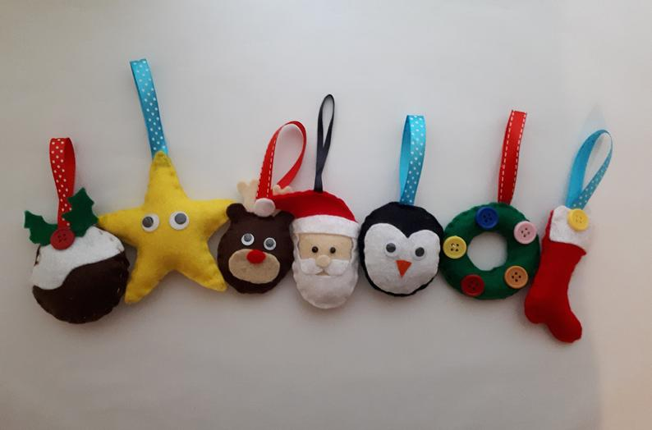
Wider Curriculum (Cooking, trips, outdoor):
Knowledge outcomes:
Use research and develop design criteria to inform the design of innovative, functional, appealing products that are fit for purpose
Generate, develop, model and communicate ideas through discussion and annotated sketches
Select and use a wider range of tools and equipment to perform practical task
Select from and use a wider range of materials and components according to their functional properties and aesthetic qualities
Investigate and analyse a range of existing products
Evaluate their ideas and products against their own design criteria and consider the views of others to improve their work
Christmas Tree Decorations

