St Mary’s C of E Primary School, Writhlington
‘Inspiring Learning Together’
Scheme of Work + Knowlegde Organiser
Key Vocabulary:
Spelling | Definition/Sentence
Samaritan | a charitable or helpful person
sin | an action that breaks a religious law
forgiveness | the action or process of forgiving or being forgiven
miracle | an extraordinary event taken as a sign of the power of God
incarnation | A person who embodies a God in the flesh

Knowledge outcomes:

The Learning Journey:
How does the story of the Good Samaritan teach us about love?
How does the parable of the Lost Son teach us about sin and forgiveness?
What is the Lord’s prayer?
What is a miracle?
What is incarnation and why is it so important to Christians?
What is the ‘true meaning of Christmas’?
Wider Curriculum
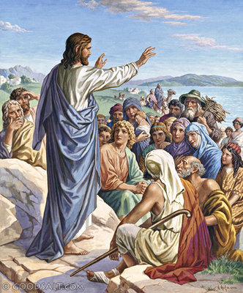

What can we learn from the life and teaching of Jesu?

