Trolls, trolls, trolls

Introduction
Trolls are everywhere on Earth. They get a bad reputation because of 1 bad troll
who would torment a farmer's goats.

What do trolls look like?
Trolls are all different. They could be green with no horns or red with nobly knees and curly, sharp horns. A troll's unique feature like our fingerprints is that the pattern on their horns is not the same as any other, even its own kind don’t have the same pattern.
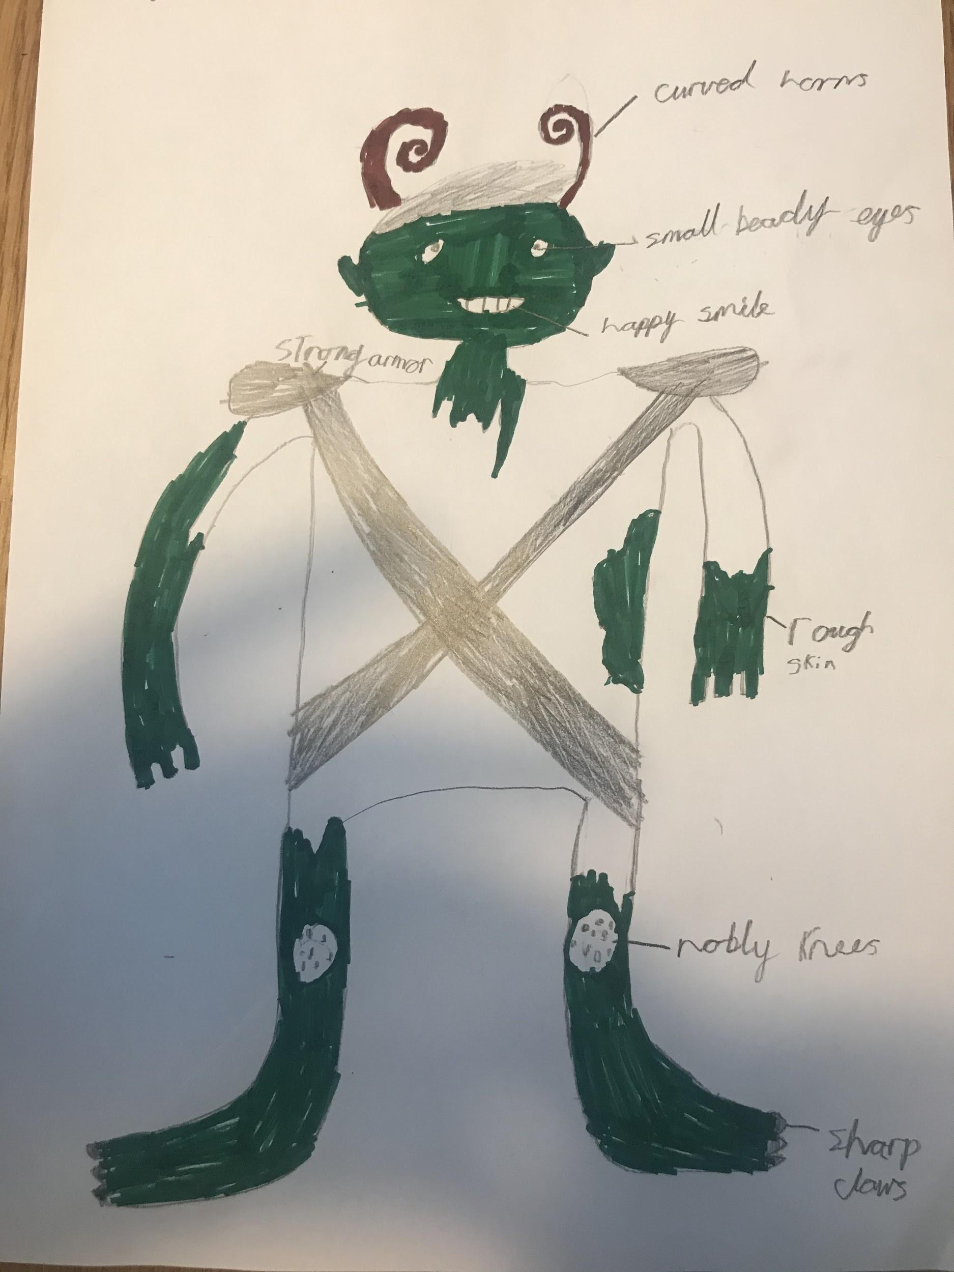 | Where do trolls live?  Trolls live in lots of places but they mostly live in a dingy cave or on high cliffs where they won't be seen by any one. Trolls can be found under bridges waiting for prey to swim by.
What do they eat?  Trolls mostly eat Scissor fish. They do eat cheese and snakes but not regularly. Occasionally, the trolls drink an odd liquid called Irash tea which is made of goats milk, tomatoes that are stolen or borrowed from a farmer, water and troll toenails that have been bitten off. Yuck! Goats aren’t actually on a troll’s menu. | Fun fact  The tea is so hot it feels sooo cold!
Did you know?
Trolls actually love people and goats. In fact, trolls keep goats and treat them as pets. Many hunters tell lies and falsely accuse trolls.

True or false?  T F  - Trolls are evil.  - There are peas in the tea.  - The troll god is called Colrither  - Trolls hate snakes  - Some trolls can fly  1.f 2.f 3.t 4.f 5.t | Myths and legends  The trolls had an ancient god like we do called Colrither the Great. All trolls thought he made Earth and worshiped him. He had wings and could fly and made the king trolls with wings think the wings came from Colrither.  