St Mary’s C of E Primary School, Writhlington
‘Inspiring Learning Together’
Scheme of Work + Knowlegde Organiser
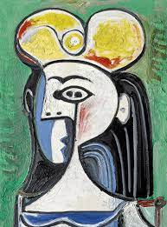
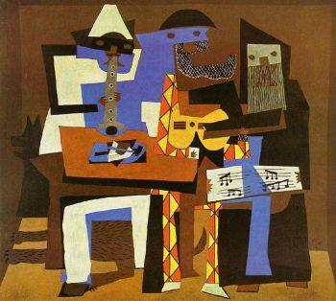
Key Vocabulary:

Tone: the lightness and darkness of a particular colour.

Portrait: the representation of a particular person.

Abstract: freedom to create artwork that is not an accurate representation.
The Learning Journey:
Who was Pablo Picasso?
The children will look at the life of Pablo Picasso and create a poster about his life and work.
What was Pablo Picasso’s work like?
Children will learn about Picasso’s early artwork in the style of portraits. Children will have a go at creating their own portrait of a peer.
What would you need to make a piece inspired by Picasso?
Children to look at the developed artwork of Picasso and discuss his abstract portraits. Children will have a go at recreating a piece inspired by him. There will be a focus on shading and tone.
Can I create a piece inspired by Picasso?
Children will use Picasso’s idea of abstract portraits to draw and paint their final piece.
Can I evaluate my Picasso inspired piece of artwork?
Children will evaluate their final piece and discuss similarities or areas to improve against Picasso’s work.

Wider Curriculum (Cooking, trips, outdoor):
Knowledge outcomes:
Create sketch books to record their observations and use them to review and revisit ideas
Improve their mastery of art and design techniques, including drawing, painting and sculpture with a range of materials (for example, pencil, charcoal, paint, clay)
Learn about great artists, architects and designers in history

Famous Artists – Pablo Picasso

