St Mary’s C of E Primary School, Writhlington
‘Inspiring Learning Together’
Scheme of Work + Knowlegde Organiser
Picture or illustration:
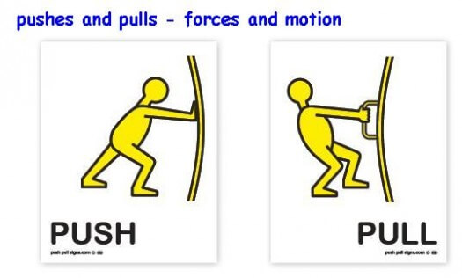
National Curriculum:
- explain that unsupported objects fall towards the Earth because of the force of gravity acting between the Earth and the falling object
- identify the effects of air resistance, water resistance and friction, that act between moving surfaces
- recognise that some mechanisms including levers, pulleys and gears allow a smaller force to have a greater effect

Wider Curriculum (Cooking, trips, outdoor):
Forest school session
Key Vocabulary:
Air resistance: a force that is caused by air with the force acting in the opposite direction to an object moving through the air.
Force: a push or pull upon an object resulting from its interaction with another object
Friction: the resistance that one surface or object encounters when moving over another
Gears: a toothed wheel that works with others to alter the relation between the speed of a driving mechanism (e.g engine) and the speed of the driven parts (e.g. the wheels)
Gravity: the force that attracts a body towards the center of the earth.
Levers: a rigid bar resting on a pivot that is used to move a heavy or firmly fixed load.
Mass: the weight measured by an objects acceleration under a given force or by the forced exerted on it by gravity
Pull force: to draw or heal towards oneself or itself, in a particular direction.
Pulleys: a wheel with a grooved rim around that changes the direction of a force applied to the cord.
Push force: to move something in a specific way by exerting force
Water resistance: a force that is caused by water with the force acting in the opposite direction to an object moving through the water

The Learning Journey:
LQ: Can I identify forces acting on an object?
- Children will explore some simple push and pull forces and the effects it has on different objects
LQ: can I explore the effect gravity has on objects and how gravity was discovered?
- Learn about Isaac Newton and the effects of gravity
LQ: Can I investigate the effects of air resistance?
- Children will explore how changes to a parachute demonstrate the power of air resistance
LQ: Can I explore the effects of water resistance?
- Children have to create an object that will float using their understanding of water resistance
LQ: Can I investigate the effects of friction?
- Children will investigate how to reduce friction
LQ: can I explore and design mechanisms?
- Children will create rube Goldberg machines using their knowledge of levers, pulleys and mechanisms.
Forces

