



**Class 3 Newsletter**

**Term 2 2020**

**v**

What a fantastic start!

Wow, what a fantastic start to the year we have had in Class 3. The children have worked so hard and should be extremely proud of themselves and everything that they have achieved – please enjoy a selection of the children’s work that they produced either in lessons or as homework. Keep up the AMAZING work Class 3!

Dates for this term

Due to the coronavirus pandemic, dates for this term are uncertain. Any important dates which do become set for the children will be communicated accordingly.

2nd November – Term 2 begins   
18th November – Film Night

18th December – Term 2 ends

Our Learning

Our topic this term is the Natural Disasters. We have already got stuck into this topic by creating our own volcanoes. We papermached plastic bottles, painted the exterior to look like a volcano and made our very own eruptions!

This term in Geography we will also explore hurricanes, tsunamis, tornados and earthquakes. We have lots of exciting things lined up!

The theme of natural disasters will continue through Literacy, beginning with the creation of our own newspaper reports. In Maths, children will develop their understanding of addition and subtraction before moving onto multiplication and division.

In Design and Technology, we will be looking at different tree decorations, with the aim of creating our own in time for the Christmas celebration.

Our topic for Science this term is ‘Animals Including Humans’. We will explore different diets, the human body and its bones and will even enjoy a world science day where we will look at famous scientist and create our own fun experiments!

In R.E. we shall be asking the question ‘What is the Trinity?’, where we will be exploring the Father, the Sun and the Holy Spirit and their meaning to Christians.

Useful Information

P.E. this term will take place on Wednesday and Thursday. Please ensure children come into school wearing P.E. kit on these days. These sessions may take place outside so please ensure that children have something warm to wear.

The children have a termly overview of the homework they are required to complete stuck in their books. Please ensure they learn the correct spellings for the week and complete at least one homework task from the termly overview. Homework will continue to be collected in on a Friday.

Please ensure that children are bringing their reading record in with them every day and that they are reading five times a week. These are checked weekly.

As we are approaching the winter months, please ensure that your child brings a coat with them every day. This will allow us to enjoy time outside even when the weather is against us.

A celebration...

Well done to Betsy, Isabelle, Olivia, Isaac, Niamh and Jemima, who completed the half term challenge and learned to tie their shoe laces!

Please enjoy a selection of the photos taken from our fire pit morning, the children thoroughly enjoyed themselves, despite the cold weather!   
 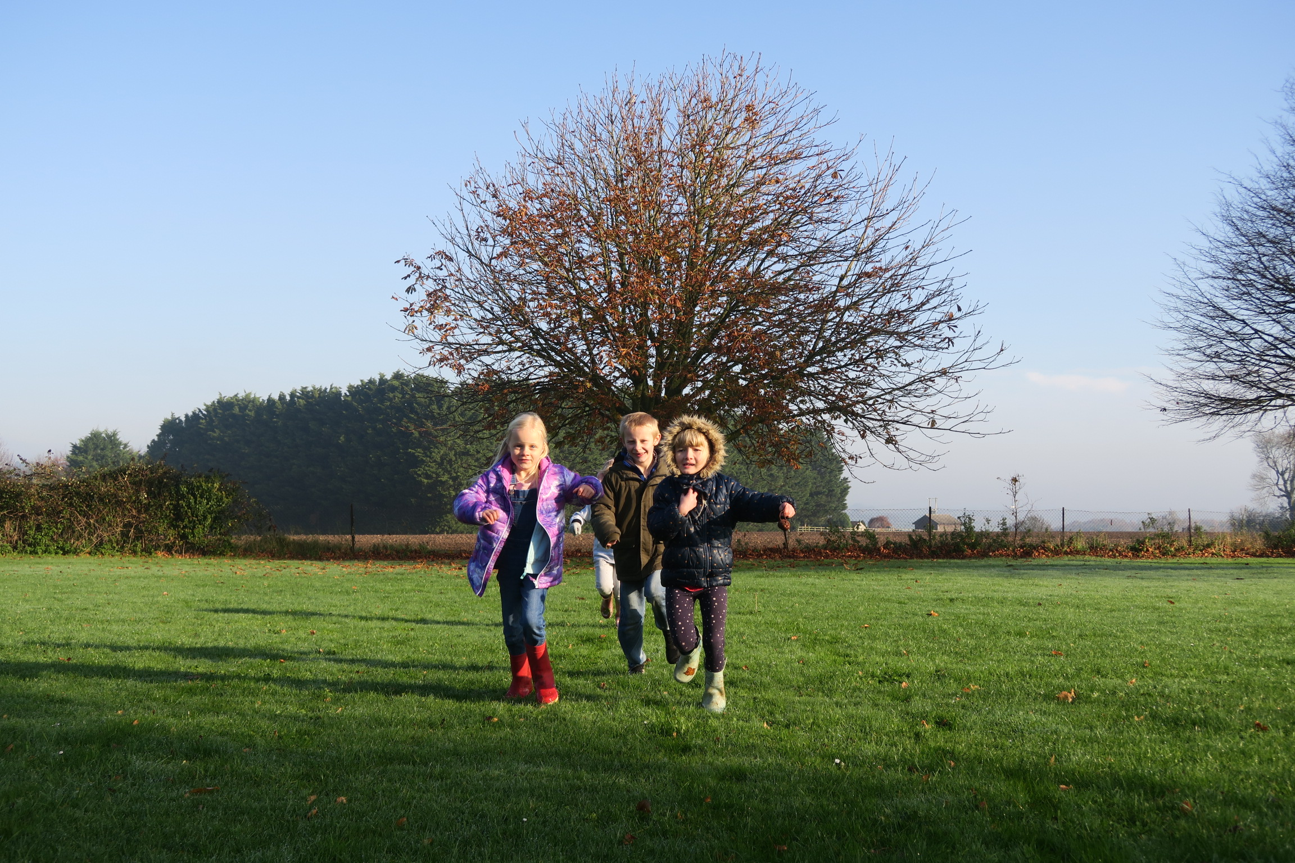 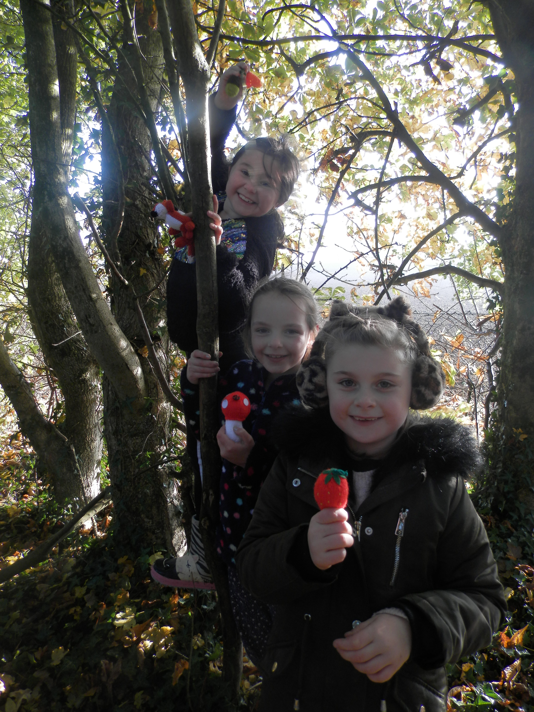 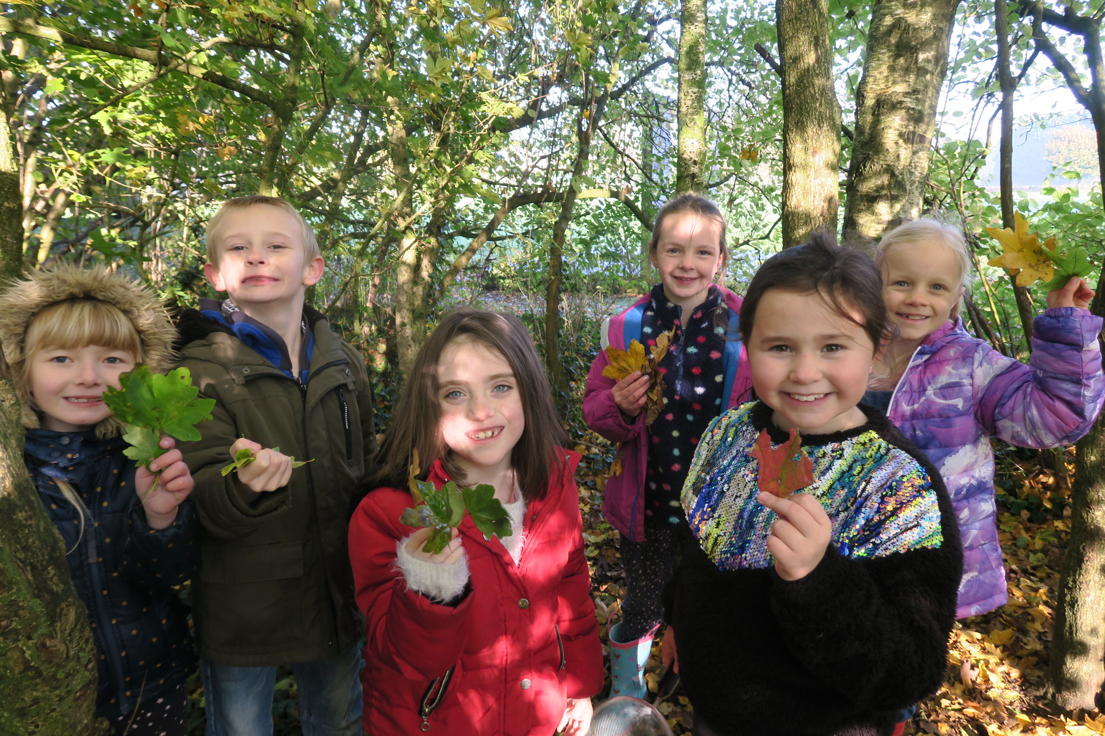

KIRF: Autumn Term 2

