**St Mary’s C of E Primary School, Writhlington**

*‘Inspiring Learning Together’*

**Scheme of Work + Knowlegde Organiser**

**Plants – Ready, Steady, Grow!**

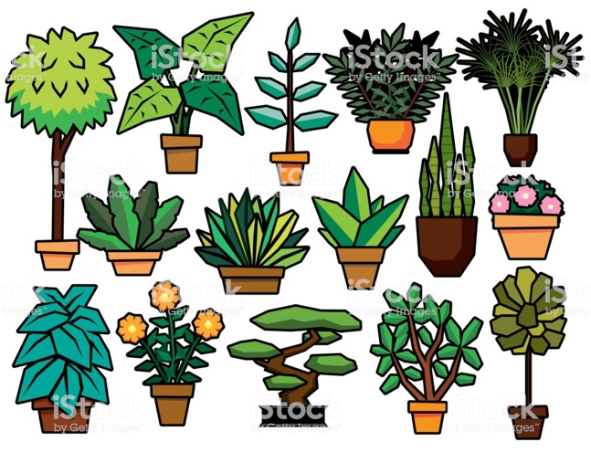

**Working Scientifically:**

Lesson 2: Setting up a fair test making careful observations.

Lesson 3: Record results using bar charts and written evaluations and conclusions.

Lesson 4: Comparative testing, recording findings,

Lesson 5: Observation of plants, dissecting and recording their ideas.

**Oracy:**

Use stem sentences to support children to contribute to discussions, record findings and draw conclusions.

Present to the class the findings of an experiment.

**Key Vocabulary:**

|  |  |
| --- | --- |
| **Spelling** | **Definition/Sentence** |
| **nutrients** | A substance that provides nourishment essential for life and growth. |
| **transport** | Take or carry from one place to another. |
| **pollination** | The transfer of pollen to allow fertilisation. |
| **fertilisation** | The action or process of fertilizing an egg or a female animal or plant. |
| **dispersal** | The process of spreading things over a wide area. |
| **germination** | The development of a plant from a seed. |

**The Learning Journey:  
  
Can I name the different parts of a plant and explain their jobs?** Children to look at a range of plants, identifying their different parts and job roles.

**What do plants need to grow?**Children will look at what plants need to grow and conduct a comparative experiment, providing plants in with different amounts of water in order to see which plant grows the most.

**What do my results show?**Children will record their data, discuss their results and present them in a bar chart.

**Can I investigate how water is transported in plants?**Children will complete another comparative experiment, looking at the effect of temperature on water transportation.

**Can I explain the different roles in pollination and fertilisation?**Children will dissect tulips in order to identify the different parts and their roles in pollination and fertilisation**.**

**Can I order the stages of the life cycle of a flowering plant?**Children to act out the different methods of seed dispersal in order to aid their understanding of the plant life cycle.

**Knowledge outcomes:**

Identify and describe the functions of different parts of flowering plants: roots, stem/trunk, leaves and flowers

Explore the requirements of plants for life and growth (air, light, water, nutrients from soil, and room to grow) and how they vary from plant to plant

Investigate the way in which water is transported within plants

Explore the part that flowers play in the life cycle of flowering plants, including pollination, seed formation and seed dispersal

**Prior Learning:**

**Year 1:** identify and name a variety of common wild and garden plants, including deciduous and evergreen trees. Identify and describe the basic structure of a variety of common flowering plants, including trees.

**Year 2:** Observe and describe how seeds and bulbs grow into mature plants. Find out and describe how plants need water, light and a suitable temperature to grow and stay healthy.