Term One Homework: The Stone Age!
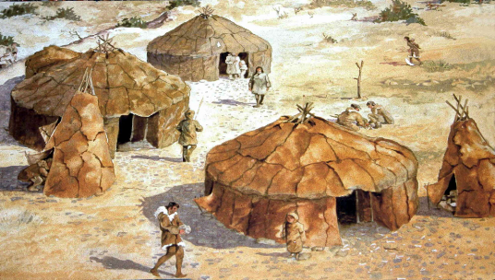
Our topic this term is Stone Age to Iron Age. To help us with our learning, please complete at least one of these tasks a week to be handed in on a Friday.
TIME TRAVELLERS – imagine you have been whisked back in time to Pre-historic Britain. You have been allowed to take one object and one person from 2020. Who and what would you take with you and why? Explain reasons for your choice.
CAVE ART – make up your own story in the style of Stone Age cave art. It can be anything you like, but you must tell it through stories!
CLOTHING – invent an outfit for a caveman or woman. Think about the materials that were available to them at the time.
PREHISTORIC ANIMALS – what animals could be found in the Stone Age? Research them and create a fact file of each. How many can you find?
HOW TO SURVIVE THE STONE AGE – create a leaflet explain how to survive the Stone Age. What will your guide say? What tips do you have for surviving? You could use ICT if you have it available!
TOOLS – what tools were used in the Stone Age, Bronze Age and Iron Ages? Research and make your own tools like those that were used in Prehistoric Britain.
STONE AGE RECIPE – Stone Age people could not pop to the shops to buy their food. Everything they are had to be caught or collected. Write your own recipe for a Stone Age dinner using the sort of ingredients that would be available to them.
CAVE HOMES – during the Stone Age, people lived in caves. If you had to live in a cave, what would it look like and who would like with you? Be as imaginative as you like. You could even make your own 3D model!

