St. Mary’s Writhlington Primary School
Where children shine

Handwriting: Guidelines
Reception
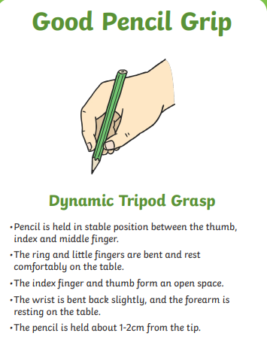
- Pre-writing stage-patterning
- Sky writing
- Individual letter formation
- Felt-tips
- Chubby Pencils
- Correct pencil grip

Year 1 pupils should be taught to:
- Sit correctly at a table, holding a pencil comfortably and correctly
- Begin to form lower case letters in the correct direction, starting and finishing in the right place
- Form capital letters
- Form digits 0-9
- Understand which letters belong to handwriting ‘families’ (see attachment) and to practise these
- Make links between phonics and spelling
- Be exposed to cursive handwriting and start practising it when ready (see attachment)
Year 2 pupils should be taught to:
- Form lower-case letters of the correct size relative to one another
- Start using some of the diagonal and horizontal strokes needed to join letters
- Write capital letters and digits of the correct size, orientation and relationship to one another and to lower case letters
- Use spacing between words that reflects the size of the letters
Year 3-4 pupils should be taught to:
- Use the diagonal and horizontal strokes that are needed to join letters
- Increase the legibility, consistency and quality of their handwriting, e.g. by ensuring that the down strokes of letters are parallel and equidistant; that lines of writing are spaced sufficiently so that the ascenders and descenders do not touch
Year 5-6 pupils should be taught to:
- Write legibly, fluently, with increasing speed and personal style by:
- Choosing which shape of the letter to use when given choices and deciding, as part of their personal style, whether or not to join specific letters e.g. x
- Choosing the writing implement that is best suited for a task (e.g. quick notes, letters)

