Reception. Little Oaks.

Phonics

Learning phonics is a very important first skill for very young children. It is a way of teaching children to read quickly and skilfully. They are taught how to recognise the sounds that each individual letter makes and the different combinations of letters, such as, ‘sh’ or ‘ee’; and blend these sounds to make a word. They will go on to ‘de-code’ new words that they hear or see. Research suggests that when phonics is taught in a structured and systematic way – starting with single sounds and progressing through to the more complex sounds found in digraphs, trigraphs, consonant blends the children make good progress with their reading and writing.

Children in Reception begin by learning to use phase 2 and will move onto use phase 3 sounds in their reading and writing…

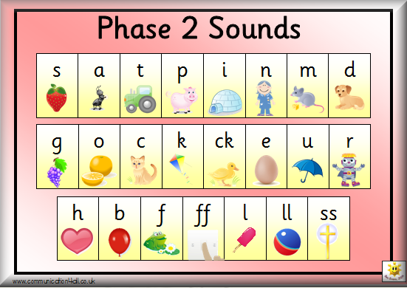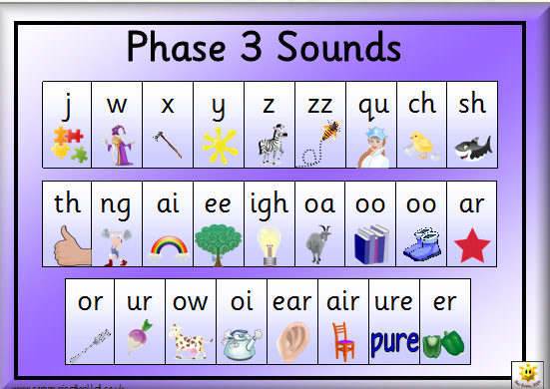

In phase 2 the children need to segment the sounds they hear in simple cvc words first.

E.g. cat dog pin dig rat

They then go onto blend them to read. It is important that they are using the correct sounds they hear. Jolly phonics songs will help with this and can be accessed online to hear how they are said correctly.

In phase 3 the children will learn lots of digraph (2 letters and one sound) and trigraphs (3 letters and one sound). Sound buttons are often used to help the children know how many sounds are in a word.

E.g.



Practising key words is vital because the next stage is to write captions and simple sentences using their phonics and key word knowledge.

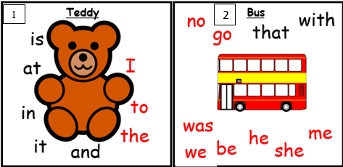

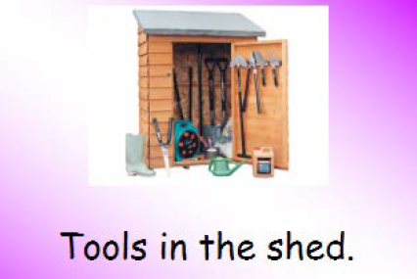

Top Tips for helping your child with phonics at home…

Go online and type in ‘Jolly Phonics Powerpoint’ in the search engine.  You can join in with the songs and be sure you are saying the phonemes correctly.

Play sound games with your children:-

* Eye spy with my little eye... something beginning with...’
* Pretend to be a robot and ‘sound talk’. Ask your child to touch or find things that you are ‘sound talking’.  E.g. “Touch your h-ea-d/find the p-e-n”.  Your child will get good at listening for the sounds in words and will eventually blend them to say and write.

Practising using sounds and key words when writing.  Write for a variety of purposes.  E.g. letters, postcards, recipes, instructions, shopping lists, everyday journal of the school holidays...