World Travel
- What does the image represent?
2. What do the landmarks represent?
3. If the image were used as an advert, what might it be advertising?
4. The image has a key message in it. Explain what you think this message is.
5. Use three adjectives to describe the image.
6. Why do you think different modes of transport are shown in the image?
7. The image represents different countries around the world. What else could it
represent?
8. What key landmarks are in the image?
9. Are there any key landmarks that you think should be included in the image? Why?
10.The weather in the image is varied. Why do you think this is? Explain your reasoning.
11.What feelings might the picture make you feel? Give three examples.
12.The image has many famous landmarks in it. Where else might you have seen images of these landmarks?

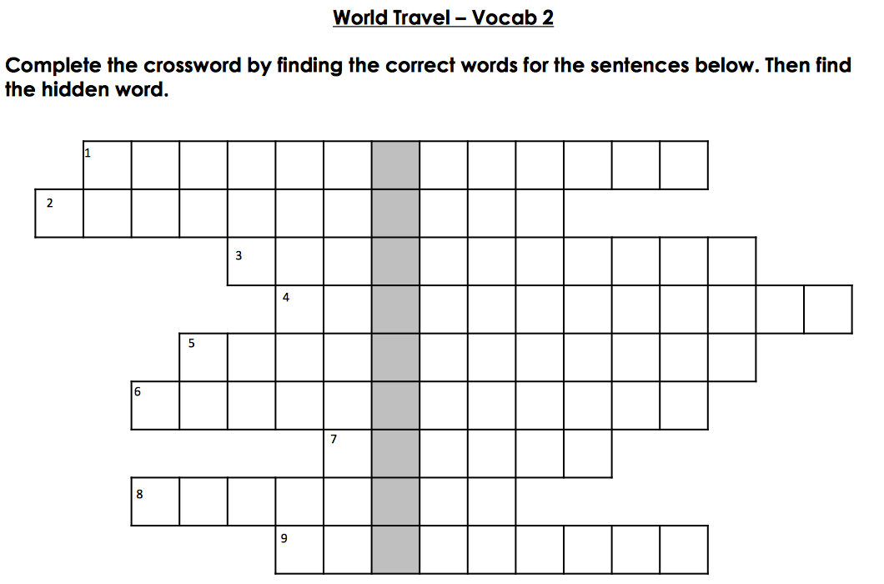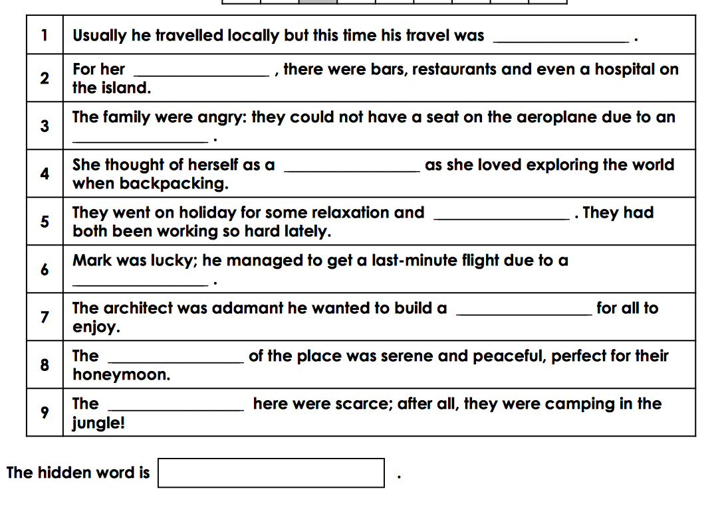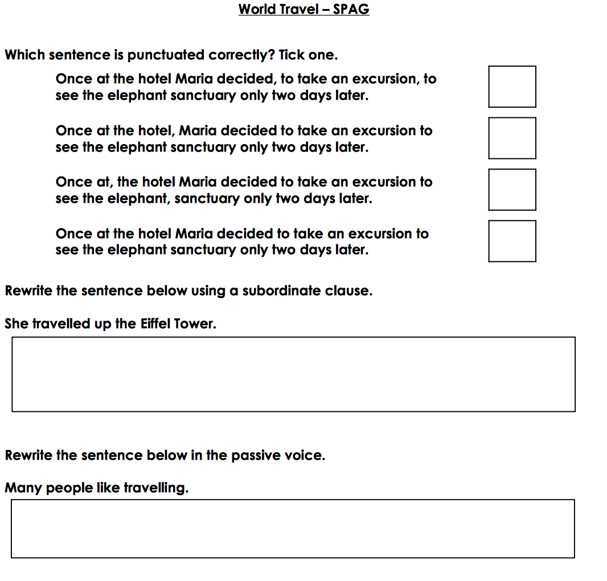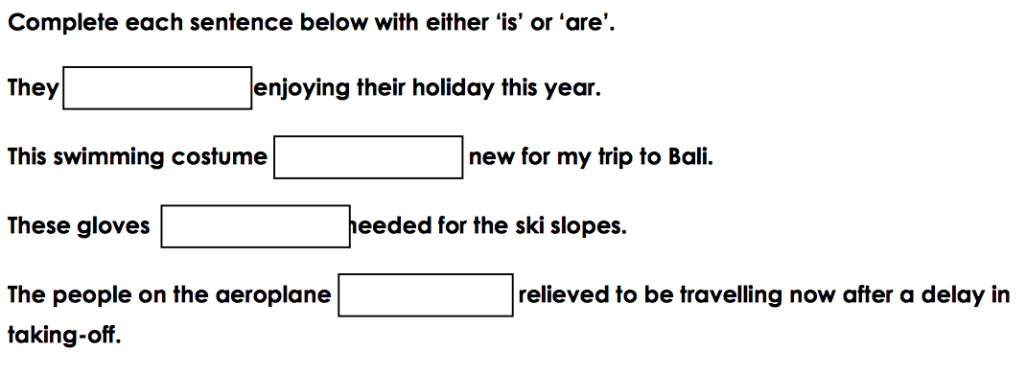

Find the definition of these words:

ambiance
amenities
availability
cancellation
convenience
globetrotter
international
overbooking
picturesque
recuperation

Create your own sentences using the vocabulary from above:

____________________________________________________________________________________________________________________________________________________________________________________________________________________________________________________________________________________
____________________________________________________________________________________________________________________________________________________________________________________________________________________________________________________________________________________
______________________________________________________________________________________________________________________________________________________________________________________________________________________________________________________________________________________________________________________________________________________________________________________________________________________________

