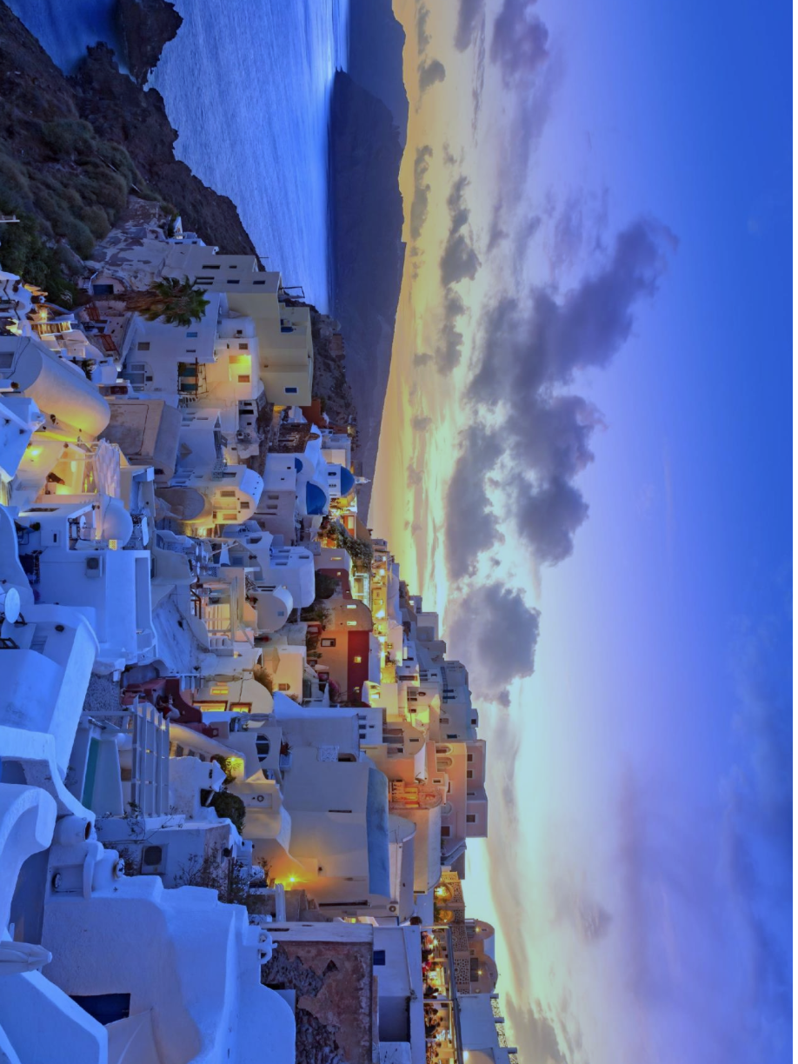
Summer Sunset
1. Where in the world could this be? What clues are there to suggest this?
2. Think of three words to describe the landscape and environment of this scene?
3. Why do you think the houses are mainly painted white?
4. What time of day do you think this is? What clues are there to suggest this?

5. How many people live here? Why do you think this?
6. How old do you think this village is? What makes you think this?

Write the definition for each of these words:

Mediterranean
coastal
dusk
environment
twilight
temperate
sparsity
climate
luminescence
inhabitants
traditional

