St Mary’s C of E Primary School, Writhlington
‘Inspiring Learning Together’
Scheme of Work + Knowlegde Organiser
The Learning Journey:
LQ: Can I research different tradition Viking amulets and make accurate observations of 3 in pencil?
- Children will record observations of different repeating patterns found of amulets they research
LQ: Can I design a Viking amulet inspired by traditional designs?
- Children will pick their favorite observations from last week to inspire their own traditional Viking amulet design.
LQ: Can I use clay to create a Viking amulet?
- Children will use their knowledge of different tools to make effective markings in clay and how to join different elements to clay using slip.
LQ: Can I use paint to enhance my Viking amulet?
- Children will use their understanding of colour theory to mix traditional colours in paint and paint their amulets.
LQ: Can I evaluate the effectiveness of my clay skills in recreating my design?
- Children will reflect on their ability to follow through with a design.
Picture or illustration:
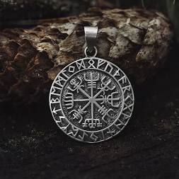
National Curriculum:
- To create sketch books to record their observations and use them to review and revisit ideas.
- To improve their mastery of art and design techniques, including drawing and sculpture using clay
Key Vocabulary:
Pattern:
Intricate
Repeated
Symmetrical
Continuous
Tessellation

Colour:
Primary
Secondary
Deep
Vibrant
Contrast

Viking Amulets

