St Mary’s C of E Primary School, Writhlington
‘Inspiring Learning Together’
Scheme of Work + Knowledge Organiser
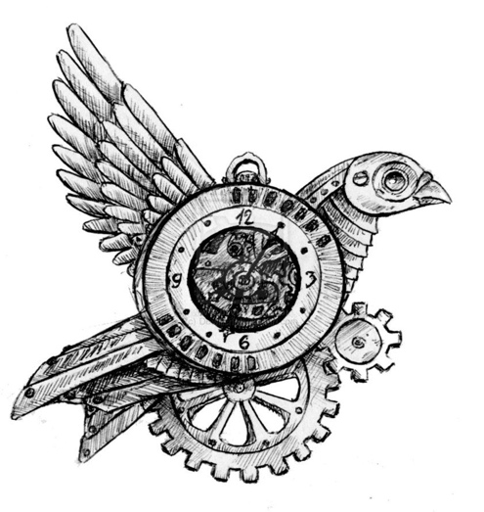
National Curriculum Knowledge outcomes:

- to create sketch books to record their observations and use them to review and revisit ideas

- to improve their mastery of art and design techniques, including drawing, painting and sculpture with a range of materials

- Continuously refer back to artists, in history for inspiration or comparison.
Skills outcomes:
- Use a variety of techniques to create form and texture i.e. shading and perspective
The Learning Journey:
LQ: Can I experiment with shading?
Drawing animals from still-life photos and paintings
LQ: Can I draw from real life?
Drawing and sketching cogs, gears and keys in a composition
LQ: Can I research an artist?
Internet research of Igor Verniy to inspire their finished piece.
LQ: Can I create an image using different skills?
Independently choosing media to create a finished image.
LQ: Can I evaluate my artwork?
Art gallery in class with parents
Wider Curriculum (Cooking, trips, outdoor):
Links with our English book – Cogheart.
Key Vocabulary:
Spelling | Definition/Sentence
Media | Materials used to create a piece of art
Shading | A range of darkness to show dark and light
Composition | The placement or arrangement of objects
Steampunk | An art movement inspired by Victorian-era fiction

Topic: Art

