St Mary’s Church of England Primary School
Class 4
Curriculum Newsletter
Welcome to the start of the new term - and what a start! The children have completed some fantastic homework related to our new World War II topic ‘Bombers and Black-Outs’.


In Term 4 the children will learn about World War II and are really looking forward to the school trip to the MShed. The children will learn to create their own WW2 newspaper reports and adventure stories.


This term we’re kicking off our Maths topic with fractions and decimals. The children will learn to identify fractions of shapes and numbers and will explore finding equivalent fractions, count in fractions and add fractions. Wow! That’s a lot of fractions knowledge!

A strong times table knowledge is essential. According to the national curriculum, children should know all of their times tables by the end of Year 4. Therefore we will continue to hold weekly times tables tests every Tuesday in preparation for the Year 4 test in June. In Maths lessons the children will reinforce their understanding of how to use their times tables in order to help them with larger, mental multiplication and division sums. They will also have opportunities to challenge each other on ‘Times Tables Rockstars’.


In Science the children will be learning all about sound. We will be investigating what materials help reduce sound and the workings of our inner and outer ear.

In DT pupils will be making Anderson Shelters and will test the structures to see how strong they are.
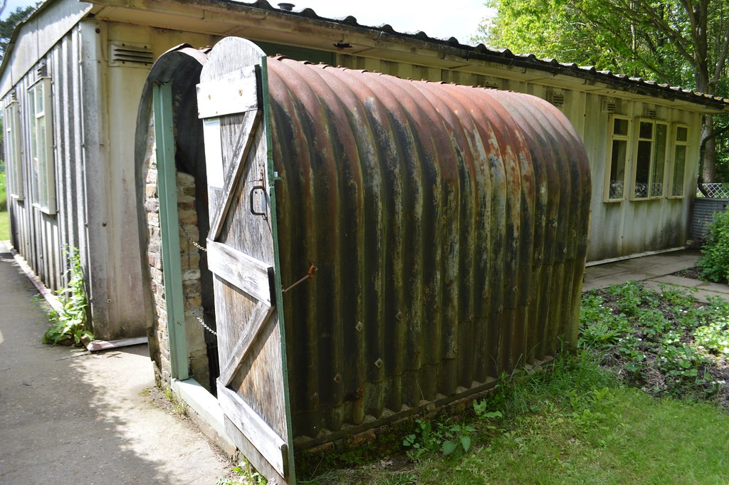


In Computing the children will discuss how technology has changed over time, research information about gadgets and write a blog post about a gadget for a class technology blog. E-safety will also feature throughout the term as the children will learn the importance of protecting themselves online and acting respectfully to others.

In RE the children will learn about what it means to belong to another religion and will study Judaism. The topic will focus on its origins, core beliefs, festivals, and special places. Children will explore the different holy books, identify key Jewish symbols and understand their meanings. If you are a practising Jew, or you know someone that is, Class 4 would like to invite you to come in to talk about your/their faith.



Targets
Early in each term targets for Literacy and Numeracy will be set. Helping your children work towards their target is a really effective way of understanding your child’s learning. It also lets your child know that their learning is valuable. Any support you are able to give to your child’s targets would be very welcome.

Class/School Awards:

Homework
In Class Four we would like the children to complete the following weekly homework tasks:

Reading: we would like the children to read at least three times a week. Reading is the skill that allows children to access other areas of the curriculum, therefore it is really important that your child is encouraged to read at home. It is great if you are able to listen to your child read out loud.

In addition, we expect the children to complete weekly Mathletics tasks and to practice their spellings and times tables at home.

- Reading Records: are checked daily (It is the children’s responsibility to change their own book).

- Spellings: are set on Monday and tested on Friday.

- Times tables: are tested every Tuesday.

- Alternate Maths and English homework will be sent out every Wednesday and collected in the following Wednesday

- Additional Maths tasks: Times table rock stars and Mathletics tasks.

- Times tables badges:
- Bronze (2x, 5x and 10x)
- Silver (3x, 4x, 6x and 11x)
- Gold (All of the times tables will be tested; 2x,5x,10x, 3x, 4x, 6x, 11x, 7x, 8x, 9x, 12x)

- ‘Above and Beyond’ Certificates
- Class achiever of the week.
- Pen Licence

Uniform
It has been great to see Class 4 looking so fantastic in their uniforms. They are immaculately turned out and really understand the importance of how wearing the correct uniform can help pupils feel proud to be part of a great school.
N.B. Please can you make sure that the children have their PE kits in school every day.

And finally…
We know how important it is to have a strong home/school partnership, so if you have any questions regarding your child’s time in Class 4, I am always available for quick messages at the end of the school day or I can respond to messages written in your child’s Reading Record. However, if you feel you need more time please make an appointment.
We hope you find this information useful.

Mrs Dobson
Mrs Dart
Mrs Gallimore

