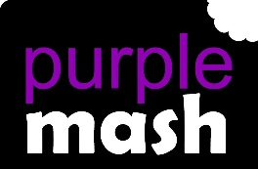
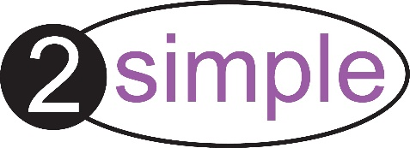
PURPLE MASH COMPUTING SCHEME OF WORK - KNOWLEDGE ORGANISER
Unit: 5.7 – Concept Maps
Key Vocabulary
Key Learning
Audience - People giving attention to something.
Collaboratively - Something that is produced by, or involves, two or more parties working together.
Concept – An idea.
Concept Map - A tool for organising and representing knowledge. They form a web of ideas which are all interconnected.
Connection - A relationship or link between two nodes or ideas.
Idea - An opinion or belief.
Node – A way to represent concepts or ideas.
Thought - An idea or opinion produced by thinking or occurring suddenly in the mind.
Visual - A picture, piece of film or display used to illustrate or accompany something.
To understand the need for visual representation when generating and discussing complex ideas.
To understand and use the correct vocabulary when creating a concept map.
To create a concept map.
To understand how a concept map can be used to retell stories and present information.
To create a collaborative concept map and present this to an audience.

Key Resources

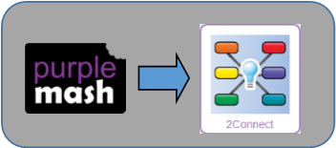

PURPLE MASH COMPUTING SCHEME OF WORK - KNOWLEDGE ORGANISER
Unit: 5.7 – Concept Maps
Key Questions
Key Images
What is a concept map?
Node | 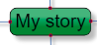
Connection
Resize node | 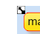
Edit node
Show story
Begin presentation
Collaboration off
Collaboration on

A concept map is a pictorial way of showing relationships between concepts and ideas. A concept map allows you to show information, pictures and links to support an idea or concept.
A concept map in 2Connect allows many users to contribute to the map which means that ideas or concepts can be quickly amended or additional information provided.
How does a concept map help share ideas?
safe?
How is information arranged on a concept map?

On a concept map ideas or concepts are organised into nodes which are linked together with lines to show how the concepts and ideas link together.

