St Mary’s C of E Primary School, Writhlington
‘Inspiring Learning Together’
Scheme of Work + Knowlegde Organiser
Key Vocabulary:
Spelling | Definition/Sentence
sketch map | a roughly drawn map that shows only basic details
symbol | graphical device used to visually represent a real-world phenomenon or a characteristic there of on a map
key | an inset on a map that explains the symbols, provides a scale, and usually identifies the type of map projection used
cartographer | a person who draws or produces maps
scale | map scale is the relationship between distance on the map and distance in real life
residential | designed for people to live in, eg houses
retail | designed to sell goods, eg shops
community | places available for people living in the same place to use
recreation | places available for enjoyment

Wider Curriculum: Outdoor adventures in the local area. Links to Art and English through Narnia
Knowledge outcomes:
Use maps, atlases, globes and digital/computer mapping to locate countries and describe features studied
Use fieldwork to observe, measure, record and present the human and physical features in the local area using a range of methods, including sketch maps, plans and graphs, and digital technologies.
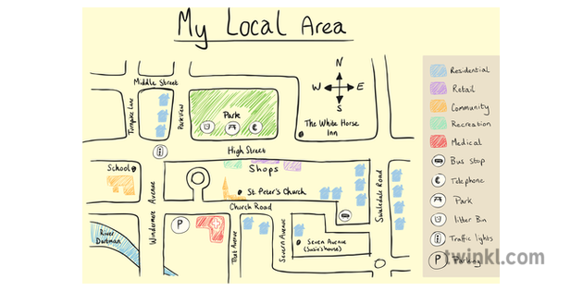
The Learning Journey:
Can I use a sketch map?
Children will be introduced to the idea of a sketch map, which they will use to navigate themselves from one landmark to another.
Can I use a key?
Children will explore how the use of a key can aid their understanding of a map and the local area.
Can I create a sketch map to show how land in my local area is used?
Children will become cartographers and create their own sketch aps of the local area.
Can I create a simple map to show how land in my local area is used?
Children will discuss the similarities and differences between sketch maps and simple maps, before turning their sketch maps into map.
Can I create a map of Narnia?
Children will apply everything they have learnt in the unit so far to create their own map of Narnia, linking to our study of The Lion, The Witch and The Wardrobe, in English. They will create their own keys and grid references. They will write simple directions explaining how to get from one landmark to another

Marvelous Maps!

