St Mary’s C of E Primary School, Writhlington
‘Inspiring Learning Together’
Scheme of Work + Knowlegde Organiser
Key Vocabulary:
Force: A push or pull action on an object
Direction: A course along which something moves
Strength: How strong something is
Forward: A direction that is facing or traveling towards the front
Backwards: A direction that is facing or travelling towards the back.
Magnet: An object which produces an area of magnetic force around itself.
Attract: Exert a force on an object that is directed towards the source.
Repel: A drive or force back or away
Predict: Say or estimate what will happen
The Learning Journey:

Which forces act upon objects?
Children receive a letter from a scientist who requires their help with science. Children investigate push and pull forces.

Which materials are magnetic?
Children sort different household items depending on whether they are magnetic or not.

Do different conditions affect the strength of a magnet?
Children to consider what might affect the strength or a magnet. Using some of these ideas, children to design their own experiment to test a prediction.

Can I investigate the effects of friction on different surfaces?
Children to use toy cars to test some fabrics create more friction than others.

Can I use my knowledge og magnets to design and create a game?
Children to design their own magnet game, thinking about the material they might use, time available and the amount of detail to their game.
Knowledge outcomes:
Compare how things move on different surfaces
Notice that some forces need contact between two objects, but magnetic forces can act at a distance.
Observe how magnets attract or repel each other and attract some materials and not others.
Compare and group together a variety of everyday materials on the basis of whether they are attracted to a magnet, and identify some magnetic materials.
Describe magnets as having two poles.
Predict whether two magnets will attract or repel each other, depending on which poles are facing.

May the Force be with you!
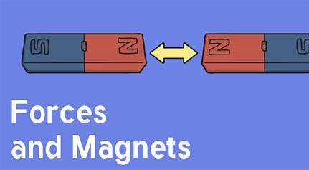
Prior learning:
EYFS-

Working Scientifically:
Lesson 1-4: setting up simple practical enquiries and comparative tests. Making systematic and careful observations. Recording findings using simple scientific language, drawings, labelled diagrams, keys, bar charts, and tables. Using results to draw simple conclusions, make predictions for new values, suggest improvements and raise further questions. identifying differences, similarities or changes related to simple scientific ideas and processes.reporting on findings from enquiries, including oral and written explanations, displays or presentations of results and conclusions.using straightforward scientific evidence to answer questions or to support their findings.

