St Mary’s C of E Primary School, Writhlington
‘Inspiring Learning Together’
Scheme of Work + Knowlegde Organiser
The Learning Journey:
Can I compare and group everyday materials?
- Compare and group together everyday materials on the basis of their properties, including their hardness, solubility, transparency, conductivity and response to magnets
What substances dissolve in liquid?
- Know that some materials will dissolve in liquid to form a solution, and describe how to recover a substance from a solution
Can I demonstrate that I understand the difference between a solid a liquid and a gas?
- Use knowledge of solid, liquids and gases to decide how mixtures might be separated, including filtering, sieving and evaporating
Can I give uses for everyday materials?
- Give reasons based on evidence from comparative and fair tests, for the particular uses of everyday materials, including metals, wood and plastic.
Can I show some reversible changes?
- Demonstrate that dissolving, mixing and changes of state are reversible changes.
Can I demonstrate my understanding of irreversible changes?
- Explain that some changes result in the formation of new materials, and that this kind of change I not usually reversible, including changes associated with burning and the action of acid on bicarbonate of soda.

Wider Curriculum (Cooking, trips, outdoor):

National Curriculum:
Pupils should be taught to:
- compare and group together everyday materials on the basis of their properties, including their hardness, solubility, transparency, conductivity (electrical and thermal), and response to magnets
- know that some materials will dissolve in liquid to form a solution, and describe how to recover a substance from a solution
- use knowledge of solids, liquids and gases to decide how mixtures might be separated, including through filtering, sieving and evaporating
- give reasons, based on evidence from comparative and fair tests, for the particular uses of everyday materials, including metals, wood and plastic
- demonstrate that dissolving, mixing and changes of state are reversible changes
- explain that some changes result in the formation of new materials, and that this kind of change is not usually reversible, including changes associated with burning and the action of acid on bicarbonate of soda

Key Vocabulary:
Conductor – A material or device which allows heat or electricity to carry through
Dissolve – When something solid mixes with a liquid and becomes part of the liquid
Evaporation – The process of turning from liquid to vapour
Flexible – Capable of bending easily without breaking
Gas – An air-like fluid substance which expands freely to fill any space available
Insulator – A substance which does not readily allow the passage of heat or sound
Irreversible – Cannot be reversed back to its original state
Liquid – A substance that flows freely but can be measured by volume e.g. water or oil
Magnetic – Capabale of being magnetised or attracted by a magnet
Material – The matter from which a thing is or can be made from
Opaque – Not able to be seen through, not transparent
Reversible – Able to be reversed back to its original state
Solid – Firm and stable in shape, not a liquid or fluid
Soluble – Able to be dissolved, especially in water
Thermal – Relating to heat
Transparent – Allows light to pass through so that objects behind can be seen

Picture or illustration: 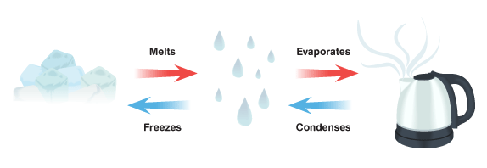
Science – Properties and changes of materials

