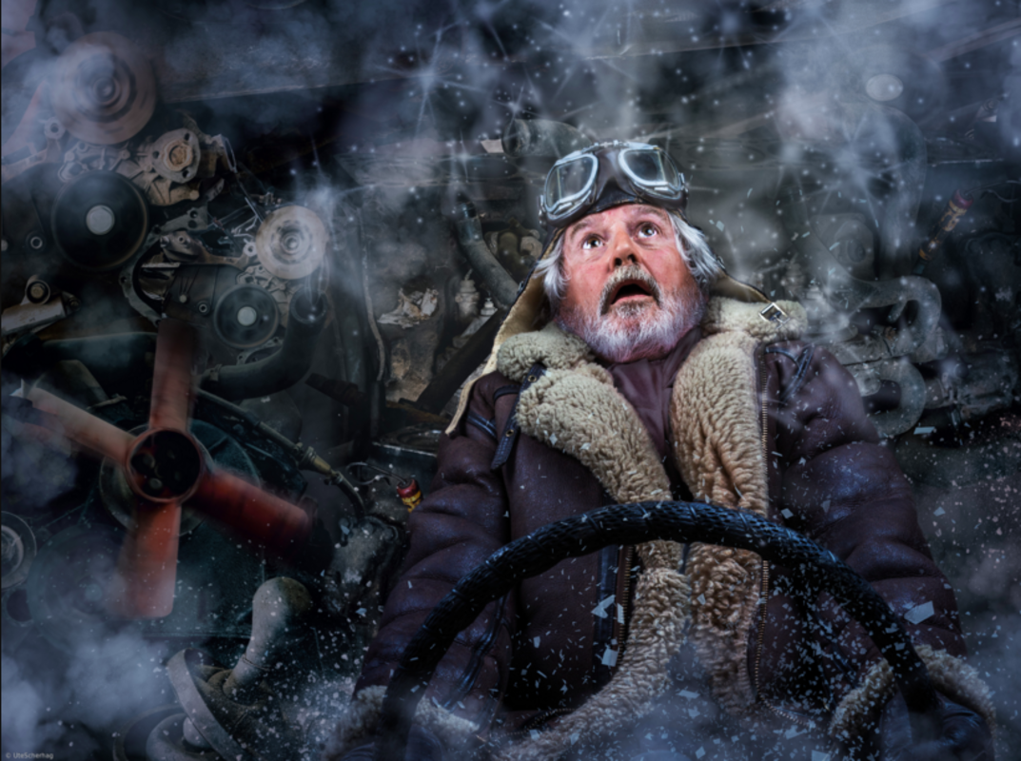

Out of Control
The driver glared at the sight in front of him. He simply couldn’t believe his eyes!
The blizzard continued to swirl all around them, making it even more difficult to steer. He knew he had to act quickly, or else it would be too late.
The distracting whirling and clanking of machinery all around him didn’t help to settle his nerves, but he knew he had to wrestle control of his emotions: his next move was to be a defining one…
_______________________________________________________________________
_______________________________________________________________________
_______________________________________________________________________
_______________________________________________________________________
______________________________________________________________________
______________________________________________________________________
______________________________________________________________________
______________________________________________________________________
______________________________________________________________________
______________________________________________________________________
______________________________________________________________________
______________________________________________________________________
_______________________________________________________________________
_______________________________________________________________________
_______________________________________________________________________
_______________________________________________________________________
______________________________________________________________________
______________________________________________________________________
______________________________________________________________________
______________________________________________________________________
______________________________________________________________________
______________________________________________________________________
______________________________________________________________________
______________________________________________________________________
_______________________________________________________________________
_______________________________________________________________________
_______________________________________________________________________
_______________________________________________________________________
______________________________________________________________________
______________________________________________________________________
______________________________________________________________________
______________________________________________________________________
______________________________________________________________________

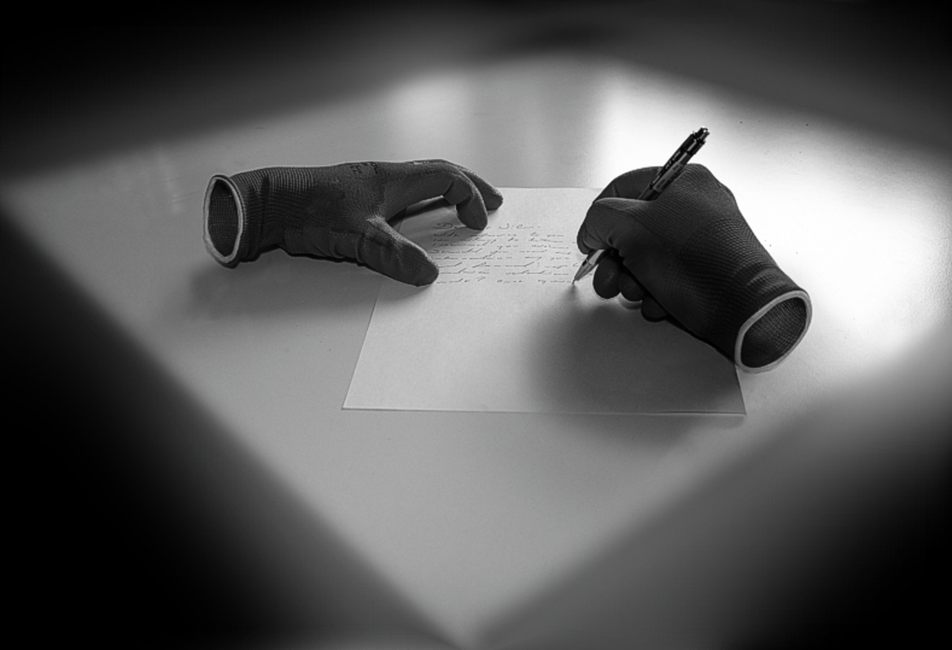
The Invisible Man
Just minutes before, everything had been completely normal. He had sat eating his breakfast at the kitchen table, as he did every day of his life.
It was only when he looked in the mirror that he realised something was wrong. For several seconds he had panicked, and a sick feeling grew in his stomach. His mouth felt dry and he started to sweat as he sprinted from room to room, trying in vain to find a reflection.
How could this have happened? Of all days, why did it have to be today? This was the most important day of his life. He had to find help…

_______________________________________________________________________
_______________________________________________________________________
_______________________________________________________________________
_______________________________________________________________________
______________________________________________________________________
______________________________________________________________________
______________________________________________________________________
______________________________________________________________________
______________________________________________________________________
______________________________________________________________________
______________________________________________________________________
______________________________________________________________________
_______________________________________________________________________
_______________________________________________________________________
_______________________________________________________________________
_______________________________________________________________________
______________________________________________________________________
______________________________________________________________________
______________________________________________________________________
______________________________________________________________________
______________________________________________________________________
______________________________________________________________________
______________________________________________________________________
______________________________________________________________________
_______________________________________________________________________
_______________________________________________________________________
_______________________________________________________________________
_______________________________________________________________________
______________________________________________________________________
______________________________________________________________________
______________________________________________________________________
______________________________________________________________________
______________________________________________________________________
______________________________________________________________________
______________________________________________________________________

