Reception. Little Oaks.
High frequency Words - The children need to know these on sight
to help with their reading. We practise these every day and practise
writing them too! We need to know how to read and write all 100 by
the end of Reception. Remember one of the sets is put in your
child’s reading record and when they can read all of that set they
will be allocated the next one. Good luck!
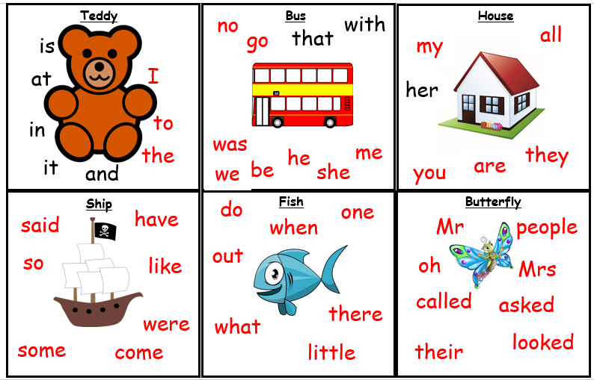
6
5
4
3
2
1
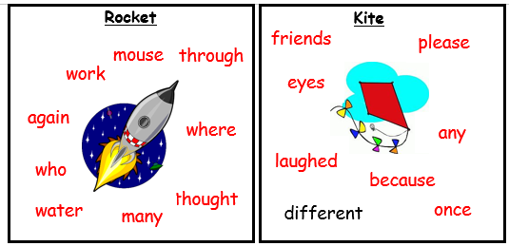
8
7

Here are also some rhymes that will help with your child’s number
formation… (See next page)
